AI + X FACULTY SHOWCASE
Live Web Apps
Front-end, AI-assisted ("vibe-coded") apps for teaching music, media, and more
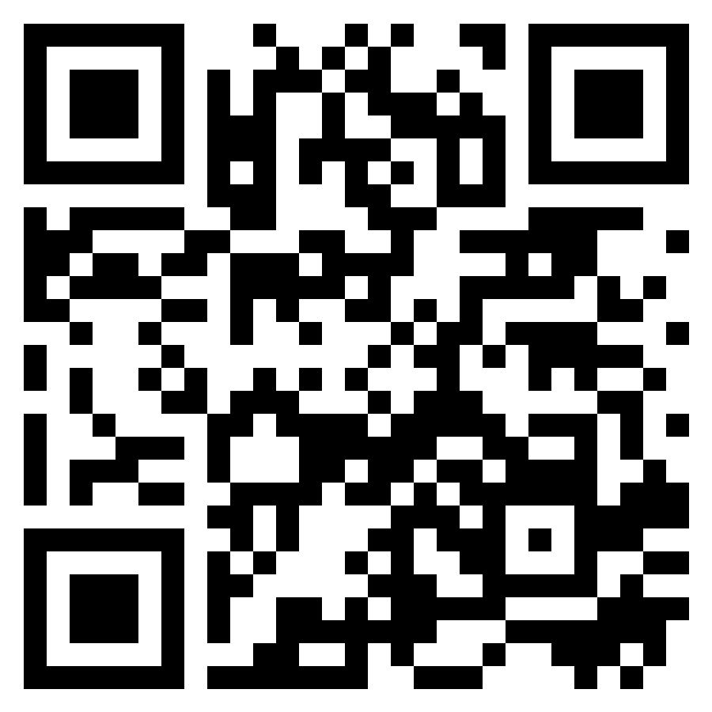
adamborecki.github.io/webapps
Adam Borecki
Chapman University
October 2026

INTRODUCTION

About this collection
This binder collects 43 live web apps I designed and built with AI coding assistants. Most began as a teaching problem in a Music Technology course at Chapman: a concept that is easier to understand by hearing it, touching it, or watching it move than by reading about it.
Every app runs in a web browser with nothing to install. They are front-end only: no server, no login, and no student data leaves the device. Each one is free to host on GitHub Pages and can be updated between class sessions.
I am not a professional software developer. These were "vibe-coded": I described what students needed in plain language, tested each build, and steered the AI through many rounds of feedback. The subject-matter expertise, design decisions, and quality control are mine; most of the code was typed by the AI.

How to use this book
Each page is one app. Point your phone’s camera at the QR code to open it, or type the short link printed under it. Many apps make sound, so turn your phone’s silent switch off and try headphones.
The appendices list every app on one page, define useful terms, explain how the apps are built, and give a step-by-step guide to making your own.

Contents
Music Technology Education · 20 apps
Mod FX · Harmonics · Harmonic Series Builder · Gain Staging · Parallel Compression · MUS 244 Unit 1 Review · MUS 244 Unit 1 Slides · Sound Lab · Salmon Simulator · Mixer Lab · EQ Trainer · OO-O-AH-A-EE · Goniometer · Comb Filter Lab · MixCube · Mid/Side Processing · Sidechain Compression · Multiband Dynamics · Multiband Mayhem · Harmonic Series Builder: Prototype Archive
Instruments & Effects · 5 apps
Sock Piano · Uke Chord Buddy · Me Again · There and Back Again · Misc Music Webapps
Multi-Discipline Education · 11 apps
Camera Lab · MUS 248 Activities · Sight Reading · Instruments · Mahler’s First · Turangalîla · Turandot: The Video Game · 8 Tiny Japanese Habits · Quiz · Note Detection · The Four Seasons
Practical Tools · 2 apps
Gym · Focus Timer
Concept & Visual · 5 apps
Hopfield · Hopfield Harmonics · Consciousness · Optics · Spirograph
Appendices: A. Index of all apps · B. Glossary · C. How these apps are built · D. Build your own

MUSIC TECHNOLOGY EDUCATION

Mod FX
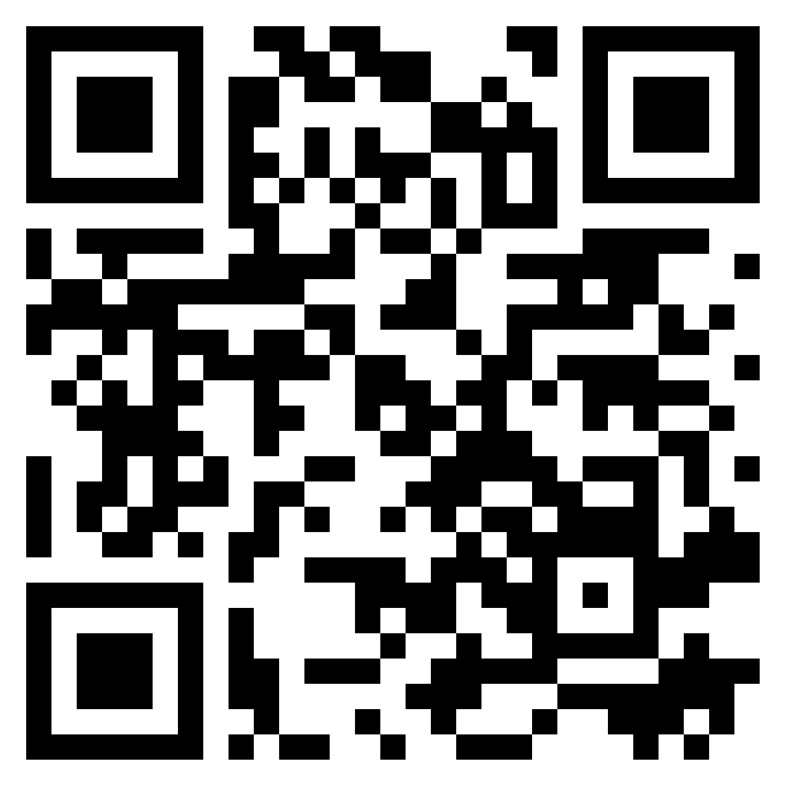
adamborecki.github.io/mod-fx/
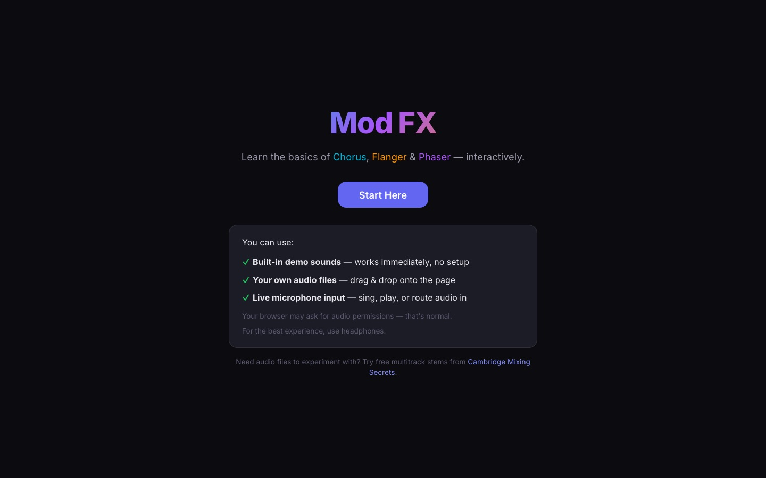
Chorus, flanger, and phaser in one interactive modulation-effects lesson.
A guided tour walks students through each effect, then a playground and quiz let them hear the difference using built-in demo sounds, their own audio files, or a live microphone.
Source code: github.com/adamborecki/mod-fx

MUSIC TECHNOLOGY EDUCATION

Harmonics
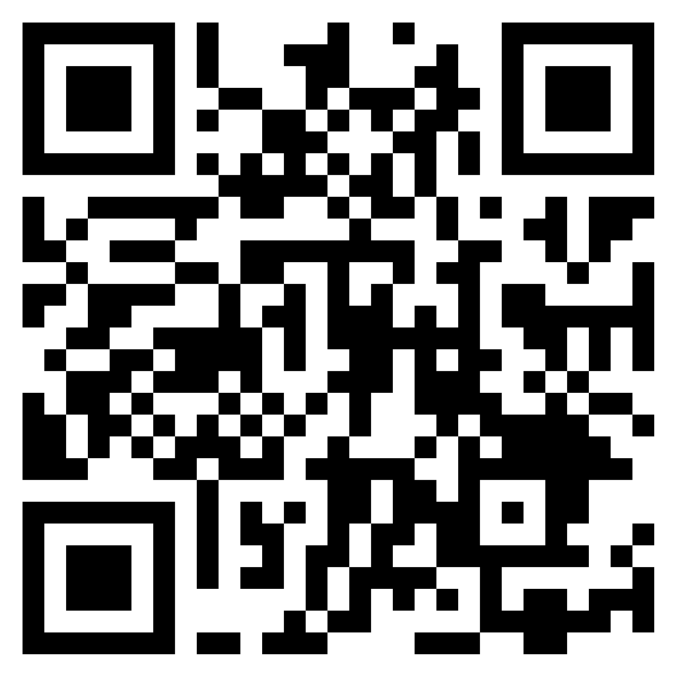
adamborecki.github.io/harmonics/
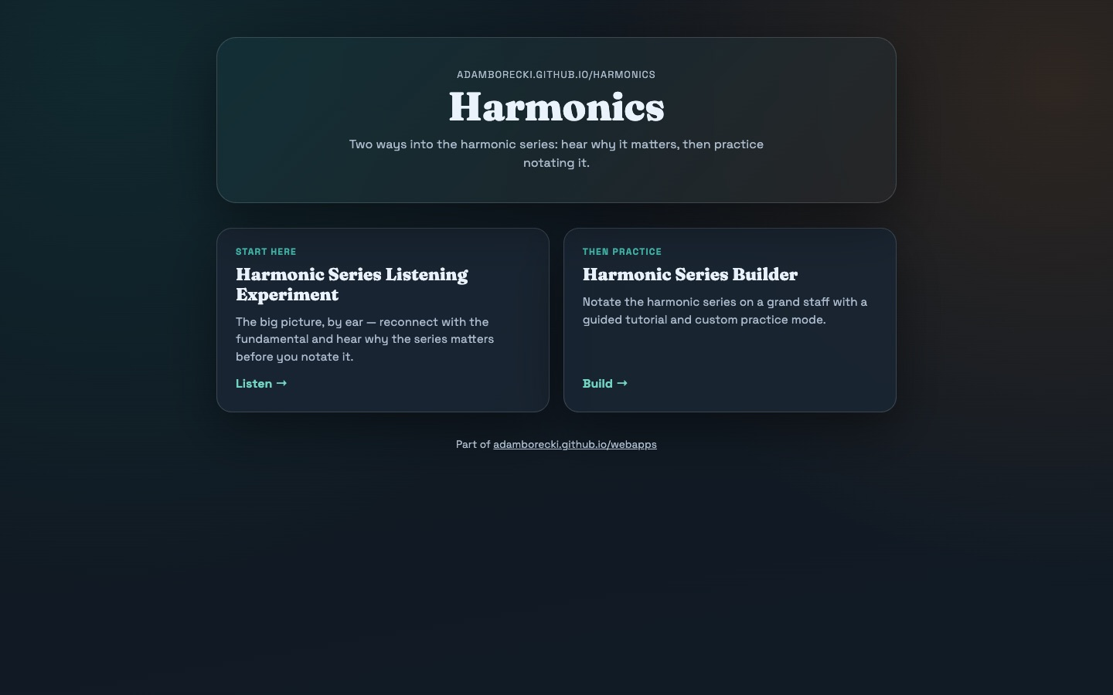
Two ways into the harmonic series: hear why it matters, then practice notating it.
A small hub that sequences a listening experiment (the big picture, by ear) before the notation builder (the practice). It is a good example of pairing an exploratory app with a drill app.
Source code: github.com/adamborecki/harmonics

MUSIC TECHNOLOGY EDUCATION

Harmonic Series Builder
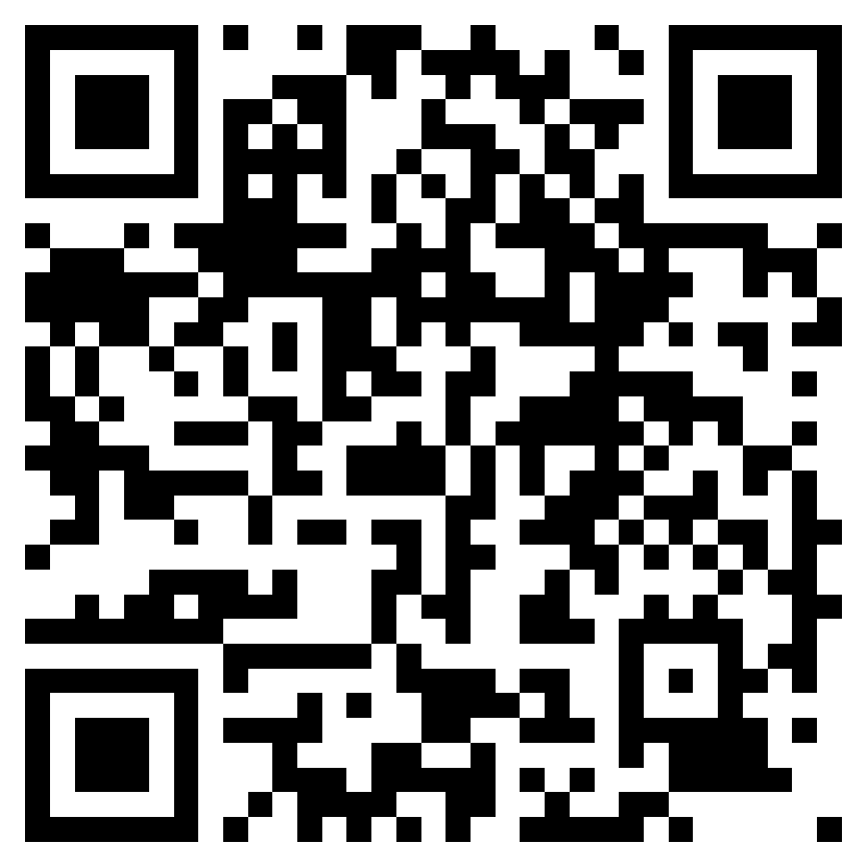
adamborecki.github.io/harmonic-series-builder-gen3/
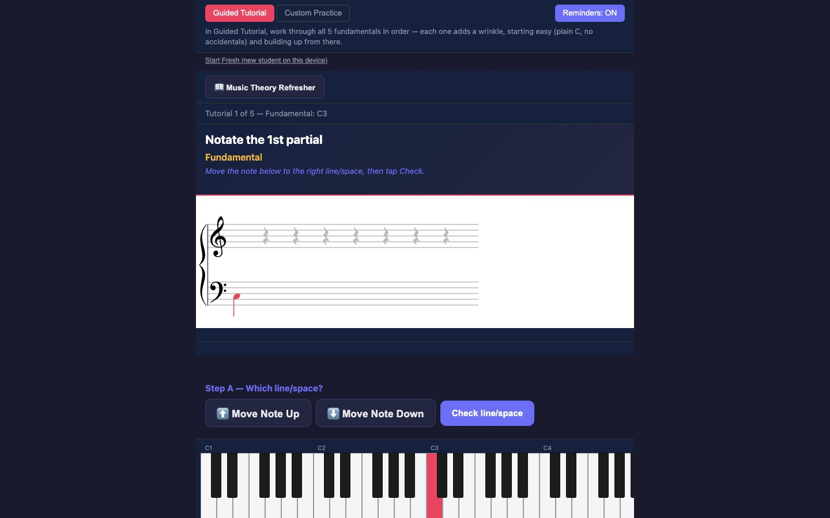
Notate the harmonic series on a grand staff with a guided tutorial and a custom practice mode.
Students place each partial on the staff, with an on-screen keyboard and step-by-step checks. This is the third generation of the app; earlier prototypes are in the Prototype Archive.
Source code: github.com/adamborecki/harmonic-series-builder-gen3

MUSIC TECHNOLOGY EDUCATION

Gain Staging
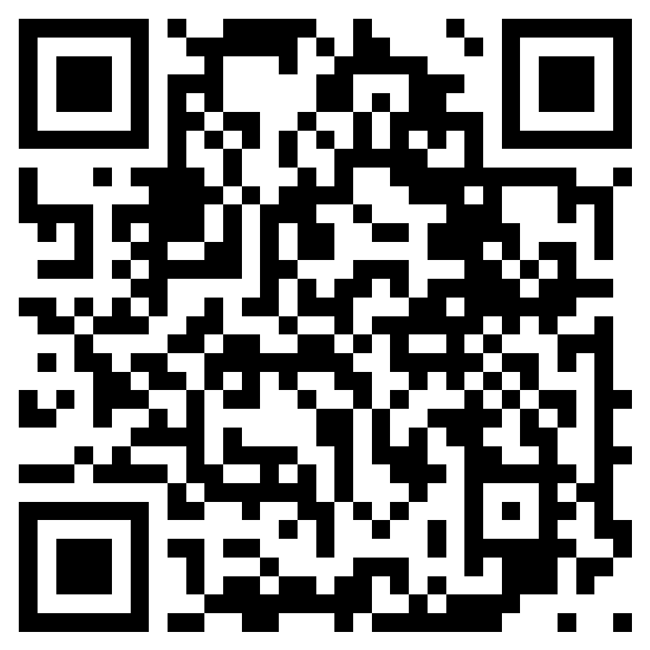
adamborecki.github.io/gain-staging/
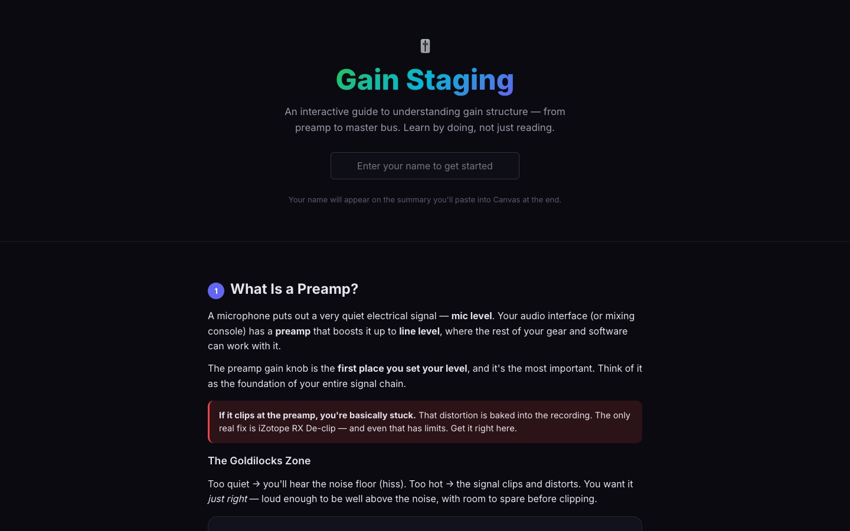
An interactive guide to gain structure, from preamp to master bus.
Students learn by doing: set a preamp, watch clipping and noise floor react, and find the "Goldilocks zone" at each stage of the signal chain.
Source code: github.com/adamborecki/gain-staging

MUSIC TECHNOLOGY EDUCATION

Parallel Compression
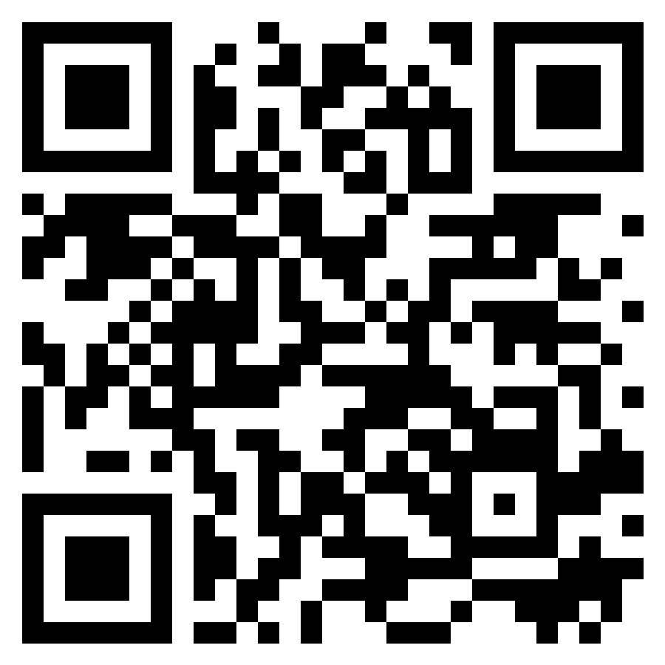
adamborecki.github.io/parallel/
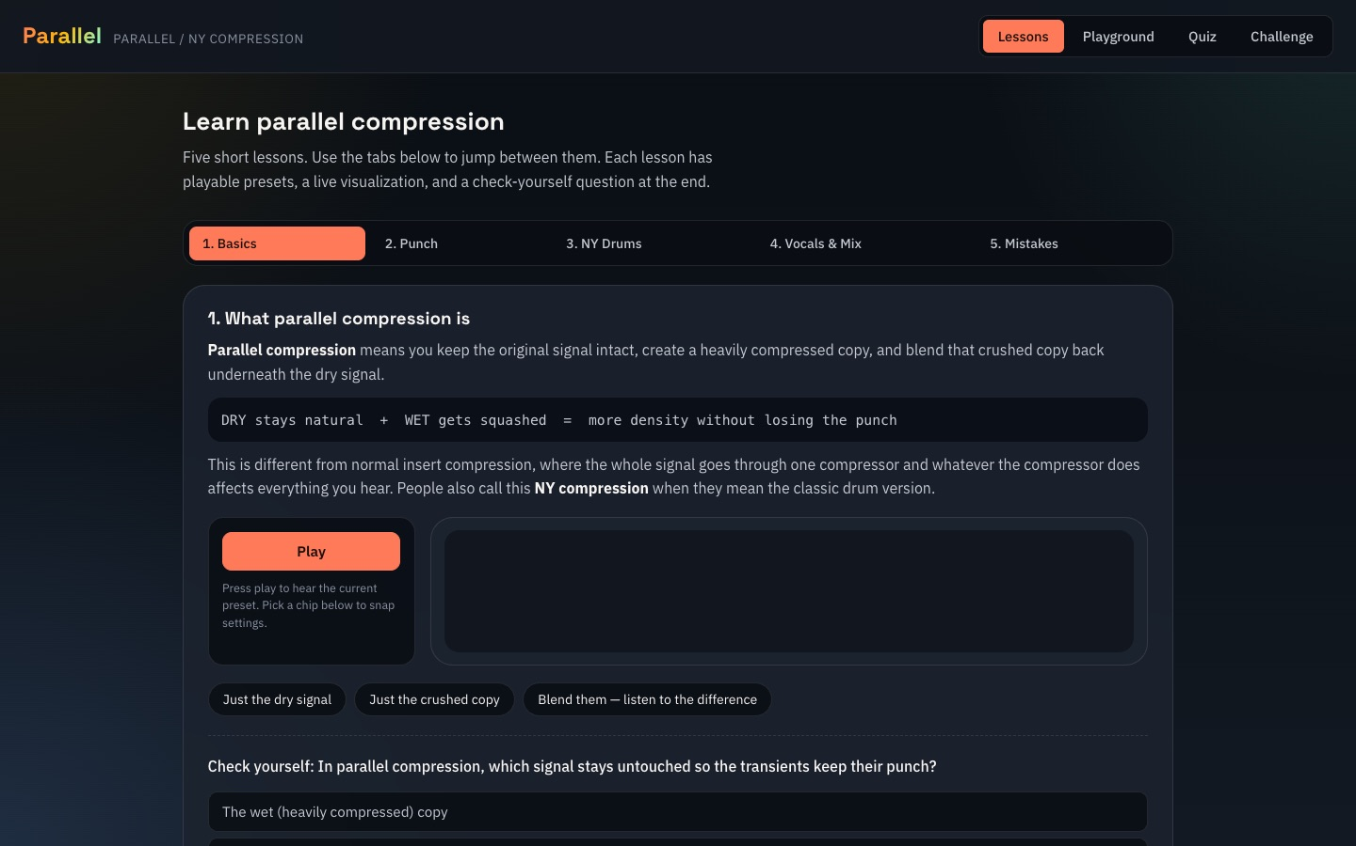
Five short lessons on parallel ("New York") compression, with playable presets.
Each lesson pairs a concept with a listening check, ending with a quiz on which signal is which in a parallel blend.
Source code: github.com/adamborecki/parallel

MUSIC TECHNOLOGY EDUCATION

MUS 244 Unit 1 Review
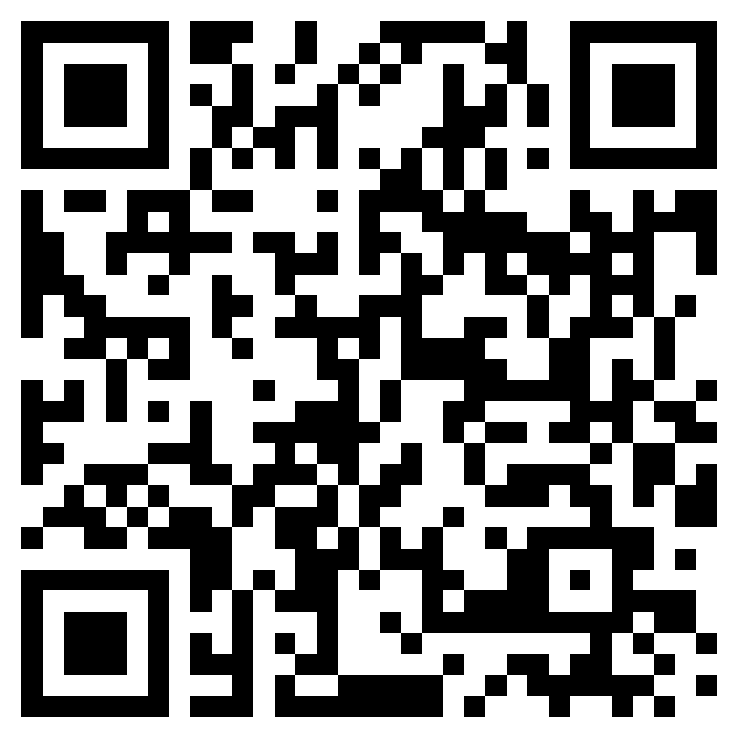
adamborecki.github.io/mus244-unit1-review/
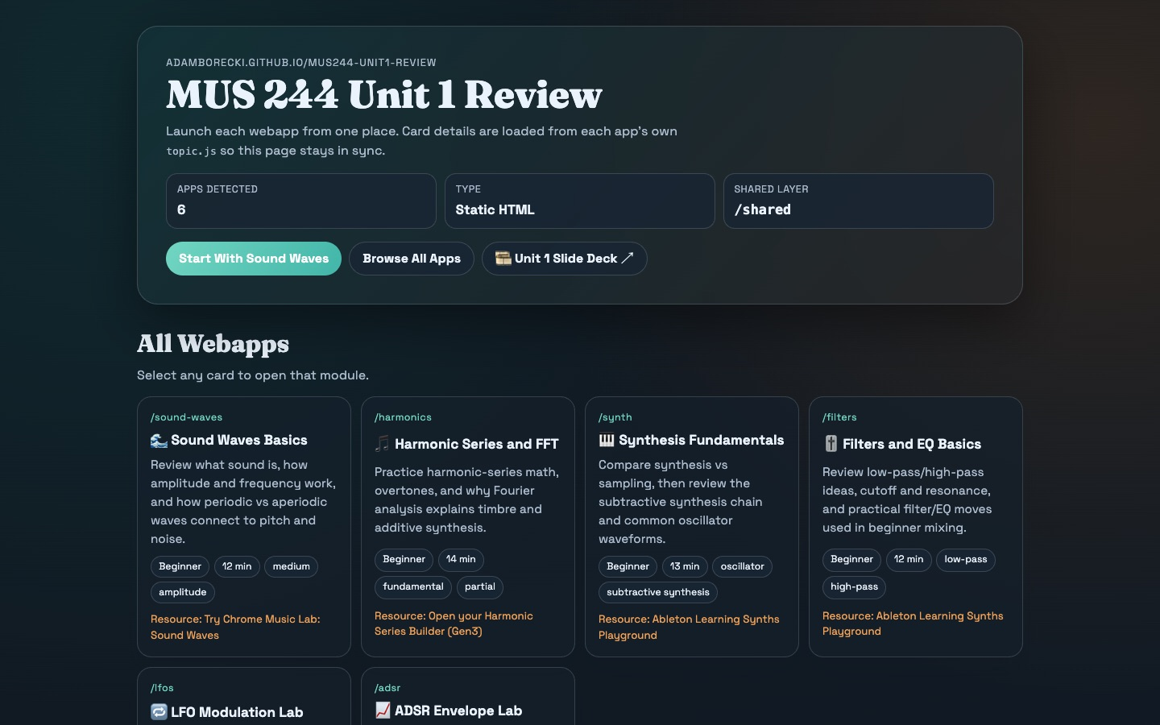
Topic reviews with quiz questions on ADSR, filters, harmonics, LFOs, sound waves, and synths.
A launcher for a set of small review apps for MUS 244 (Acoustics & Synthesis). Each card is a self-contained study module students can open before a quiz.
Source code: github.com/adamborecki/mus244-unit1-review

MUSIC TECHNOLOGY EDUCATION

MUS 244 Unit 1 Slides
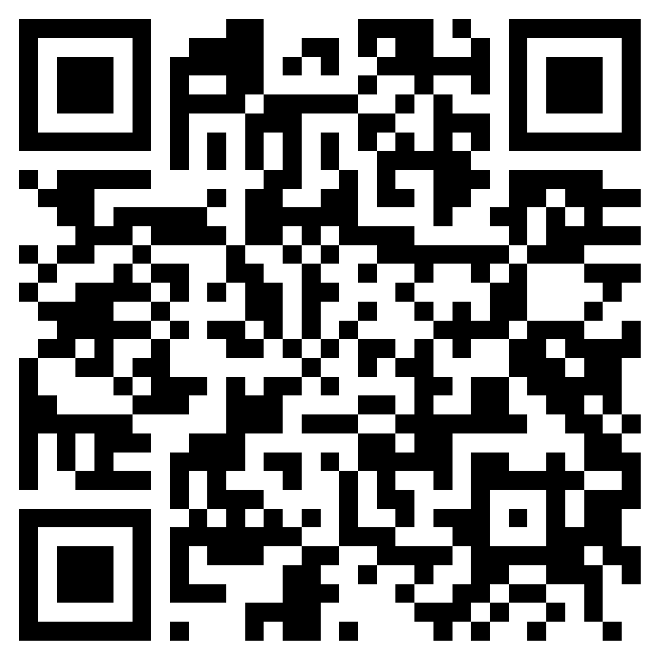
adamborecki.github.io/mus244-unit1/
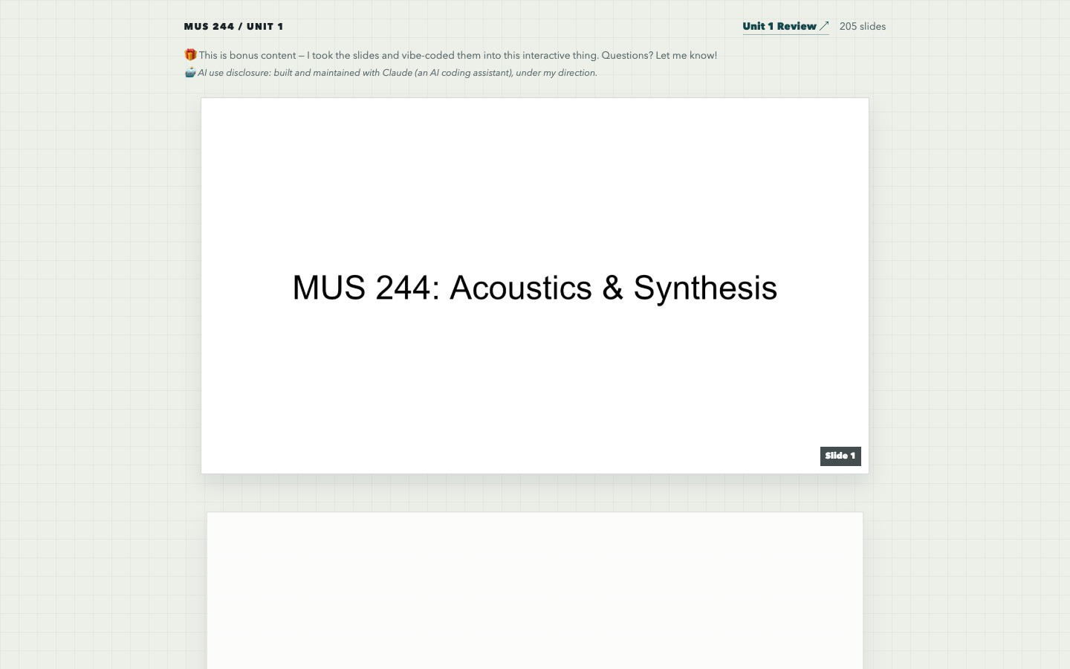
A 205-slide lecture deck for MUS 244 Unit 1, Acoustics & Synthesis, with linked follow-along notes.
The original slides, rebuilt as an interactive web page with "Explore more" links on many slides. It includes an AI-use disclosure for students.
Source code: github.com/adamborecki/mus244-unit1

MUSIC TECHNOLOGY EDUCATION

Sound Lab
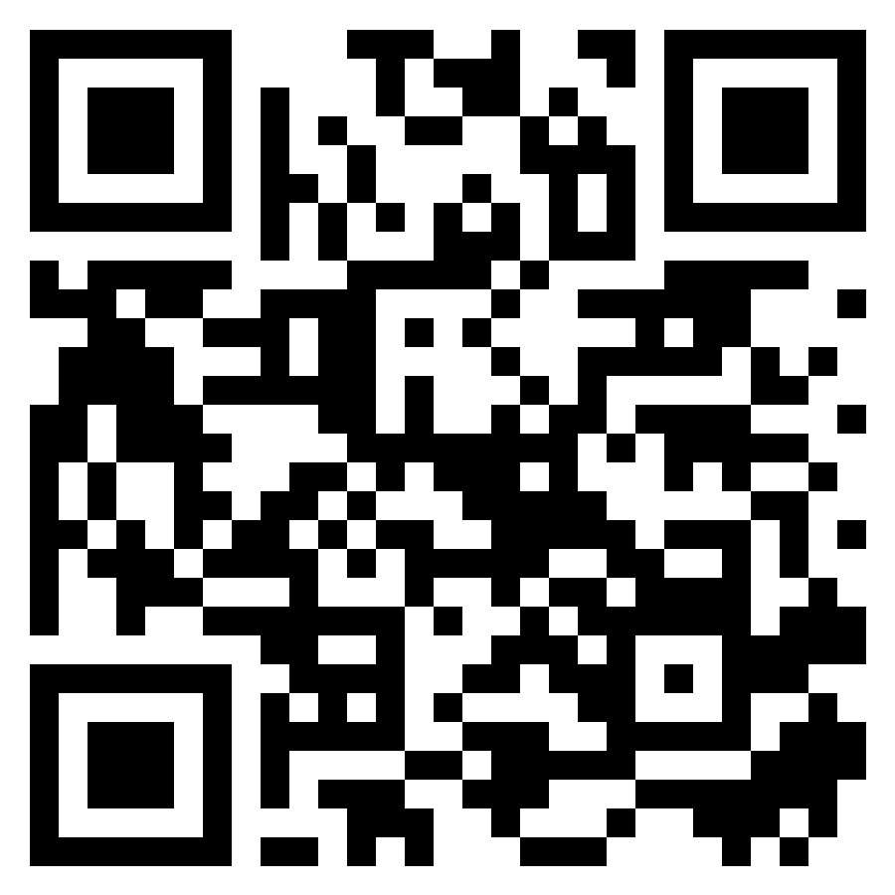
adamborecki.github.io/sound-lab/
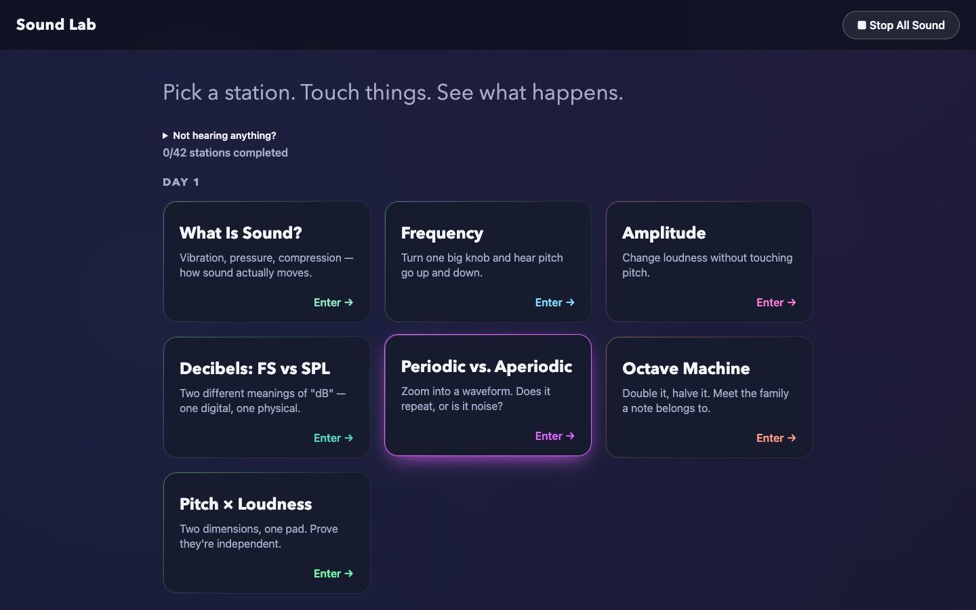
A museum-floor-style acoustics lab: touch-and-listen stations on frequency, amplitude, decibels, periodicity, and more.
Students pick a station, touch things, and see (and hear) what happens. Progress is tracked across stations, organized by class day.
Source code: github.com/adamborecki/sound-lab

MUSIC TECHNOLOGY EDUCATION

Salmon Simulator
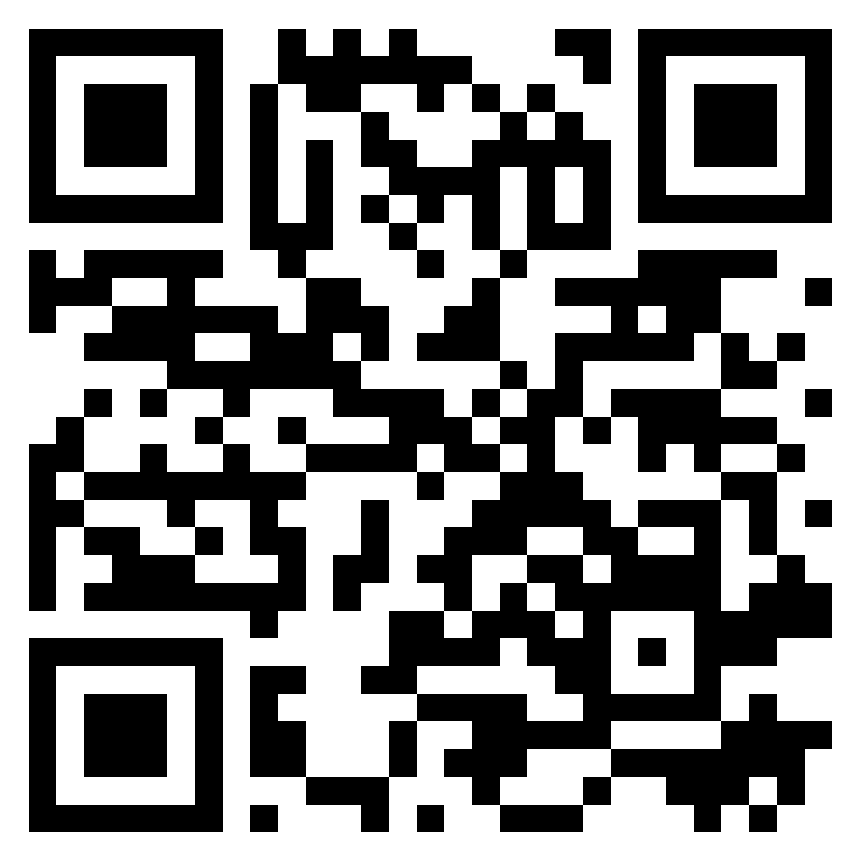
adamborecki.github.io/salmon/
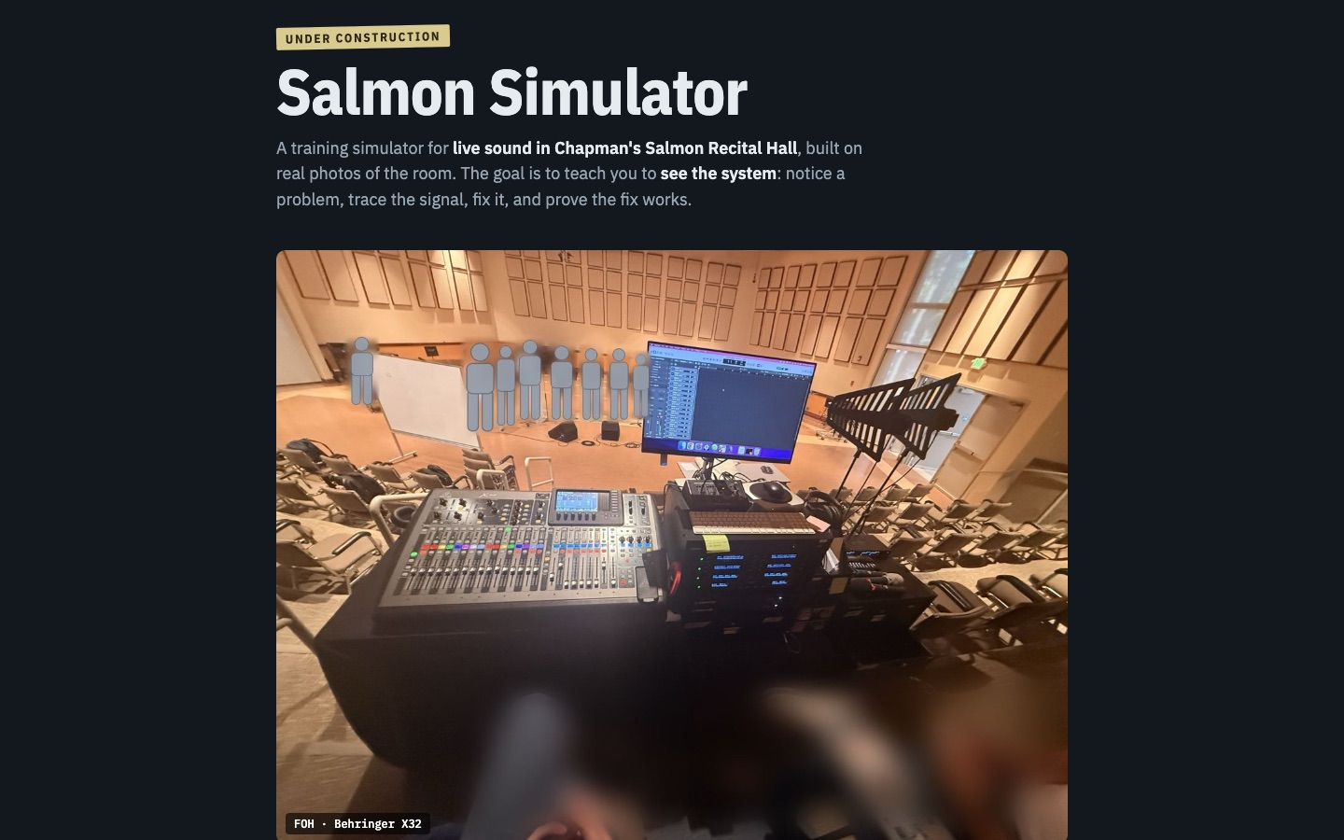
A training simulator for live sound in Chapman’s Salmon Recital Hall, built on real photos of the room.
Students walk the hall photo by photo, tap equipment to zoom in, and play a "ready by 5:00" scenario: notice a problem, trace the signal, fix it, prove the fix. A work in progress.
Source code: github.com/adamborecki/salmon

MUSIC TECHNOLOGY EDUCATION

Mixer Lab
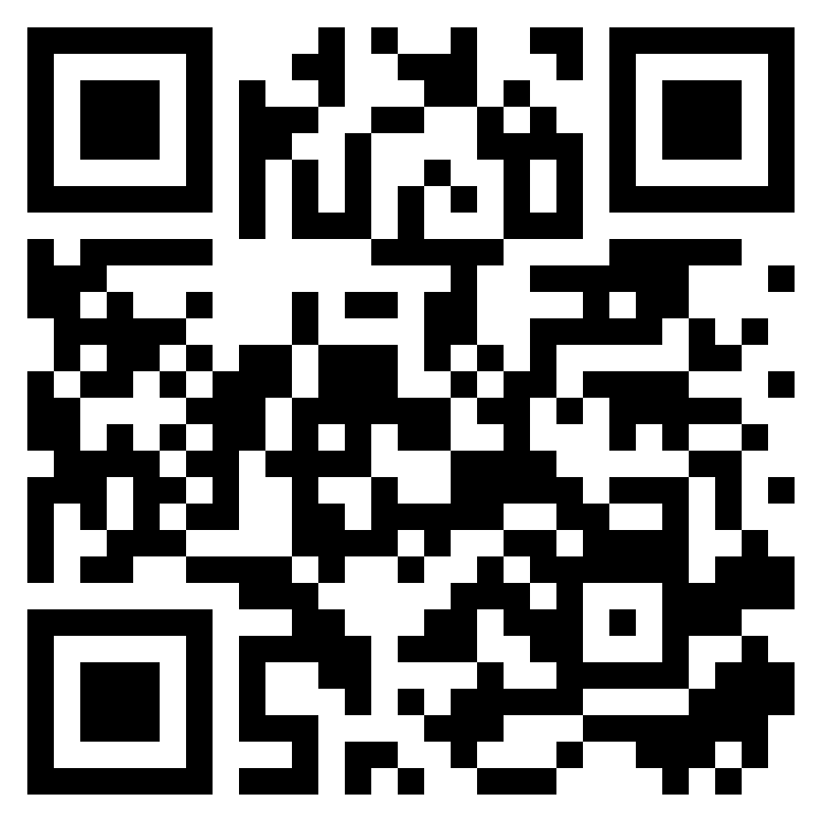
adamborecki.github.io/mixer-lab/
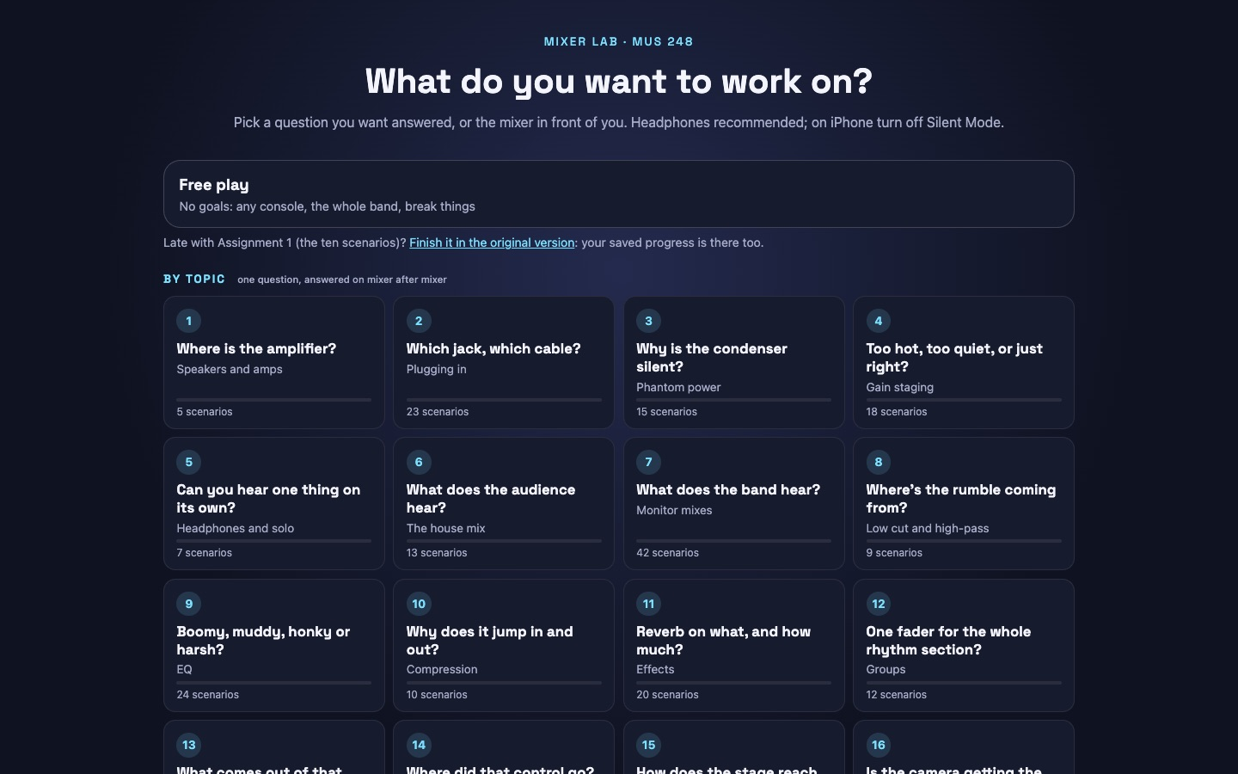
A live-sound mixer simulator: patch real band stems, set gain, build audience and monitor mixes, and find the amplifier.
Two deliberately different mixer layouts share one model, so students learn to reason about an unfamiliar board instead of memorizing one. Scenarios give plain-language feedback on bad patches.
Source code: github.com/adamborecki/mixer-lab

MUSIC TECHNOLOGY EDUCATION

EQ Trainer
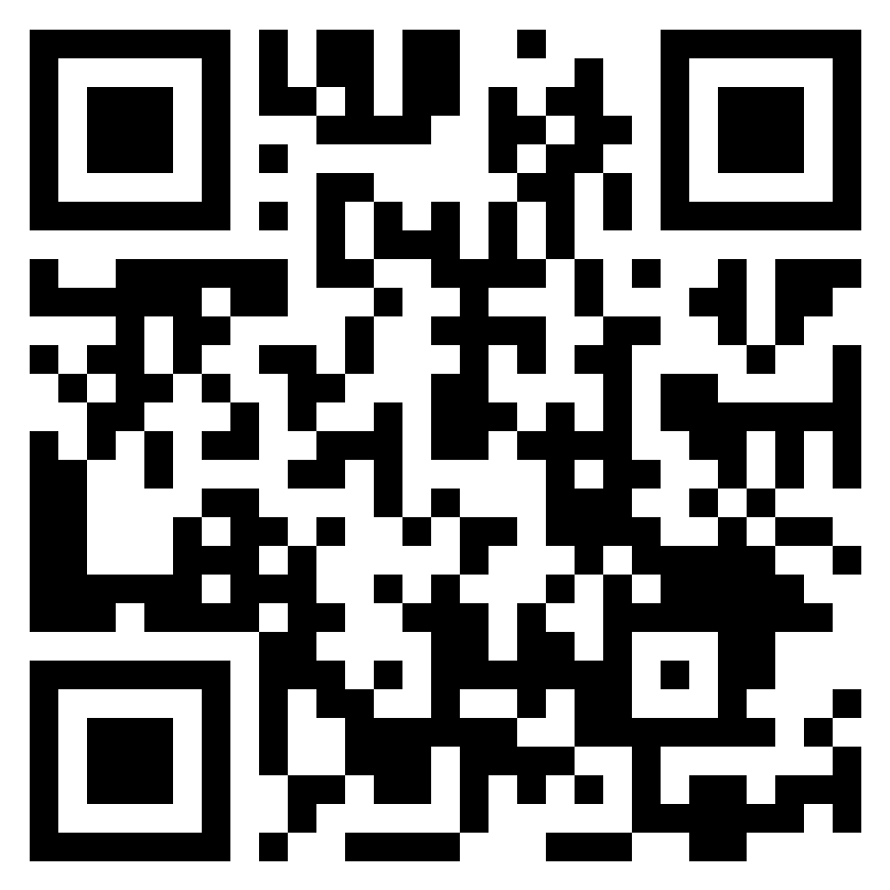
adamborecki.github.io/eq-webapp/
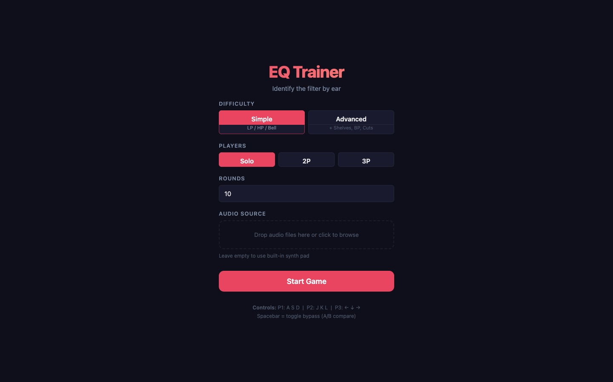
Identify filters and EQ moves by ear, in solo, 2-player, and 3-player modes.
Ear training as a game: a sound is filtered, and players race to name the filter type and frequency region.
Source code: github.com/adamborecki/eq-webapp

MUSIC TECHNOLOGY EDUCATION

OO-O-AH-A-EE
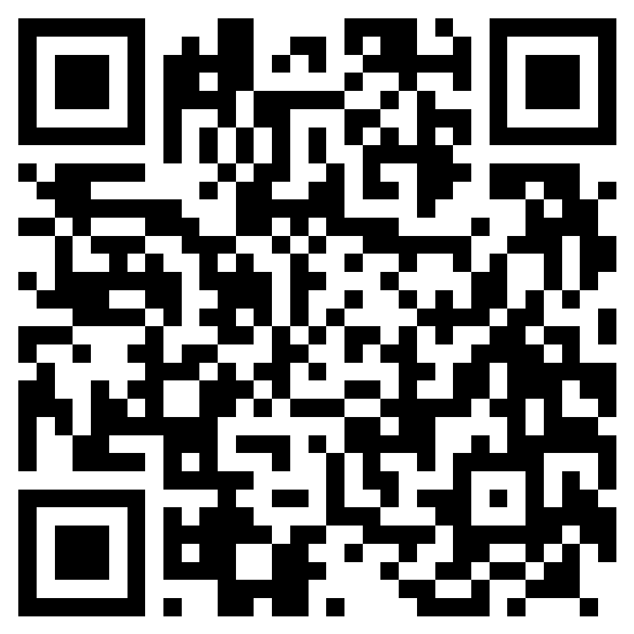
adamborecki.github.io/oo-o-ah-a-ee/
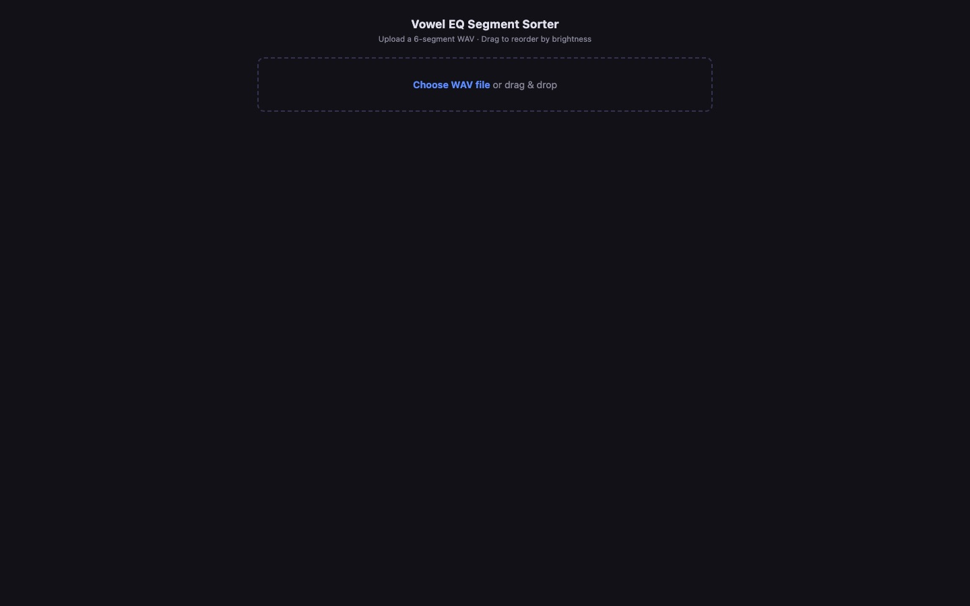
A vowel and formant trainer that maps speech sounds onto the frequency spectrum.
Students sort recorded vowel segments by brightness, with solo bands at 250 Hz to 4 kHz, to connect vowels they already know with EQ frequency ranges.
Source code: github.com/adamborecki/oo-o-ah-a-ee

MUSIC TECHNOLOGY EDUCATION

Goniometer
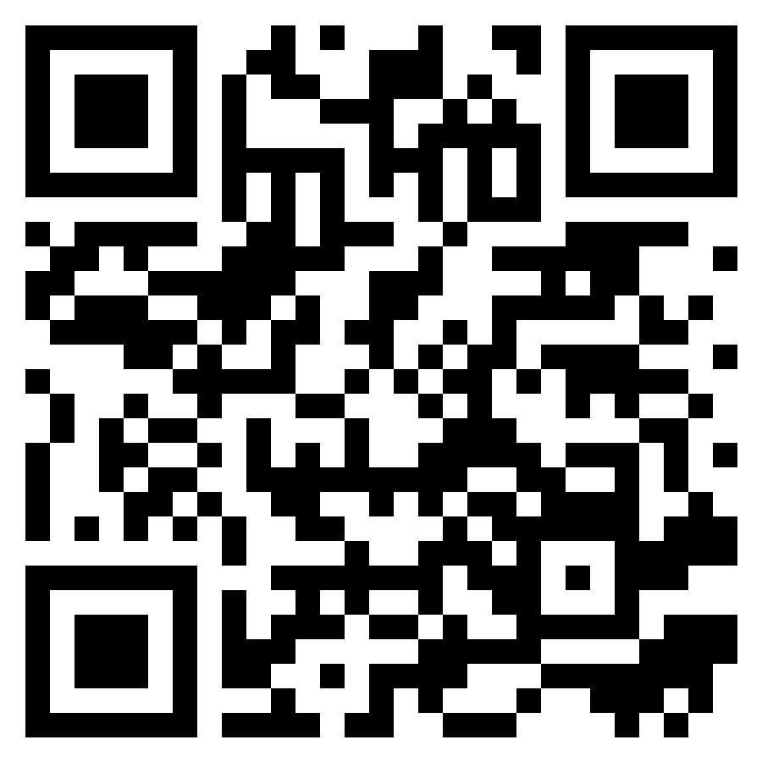
adamborecki.github.io/goniometer/
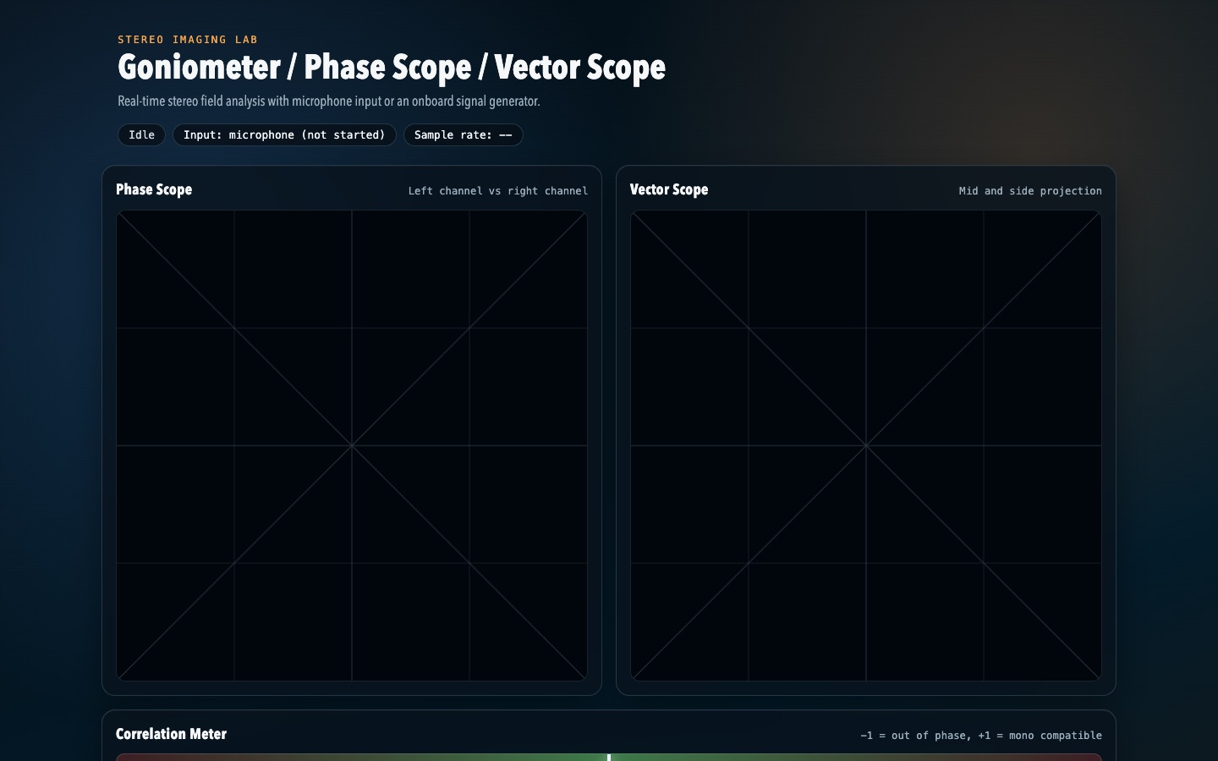
Real-time stereo field analysis with a phase scope and vector scope.
Load audio or use a demo signal and watch the stereo image, correlation, and phase relationships move in real time.
Source code: github.com/adamborecki/goniometer

MUSIC TECHNOLOGY EDUCATION

Comb Filter Lab
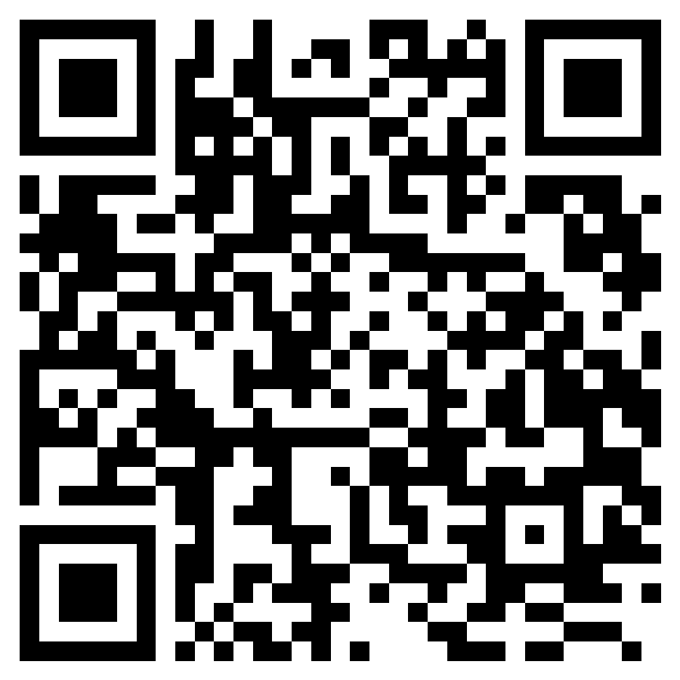
adamborecki.github.io/comb-filtering/
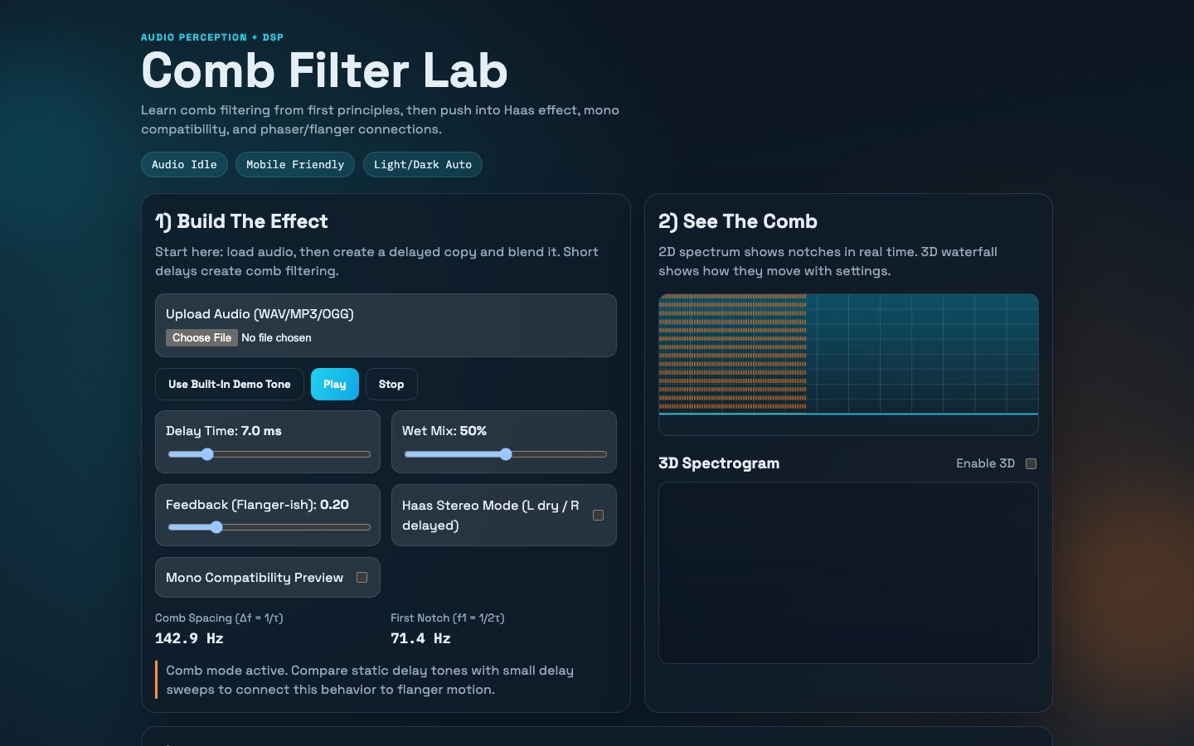
Comb filtering from first principles, into the Haas effect and mono compatibility.
Build the effect with a delay and a mix knob, see the comb in a live spectrogram, then hear why it matters when a stereo mix collapses to mono.
Source code: github.com/adamborecki/comb-filtering

MUSIC TECHNOLOGY EDUCATION

MixCube
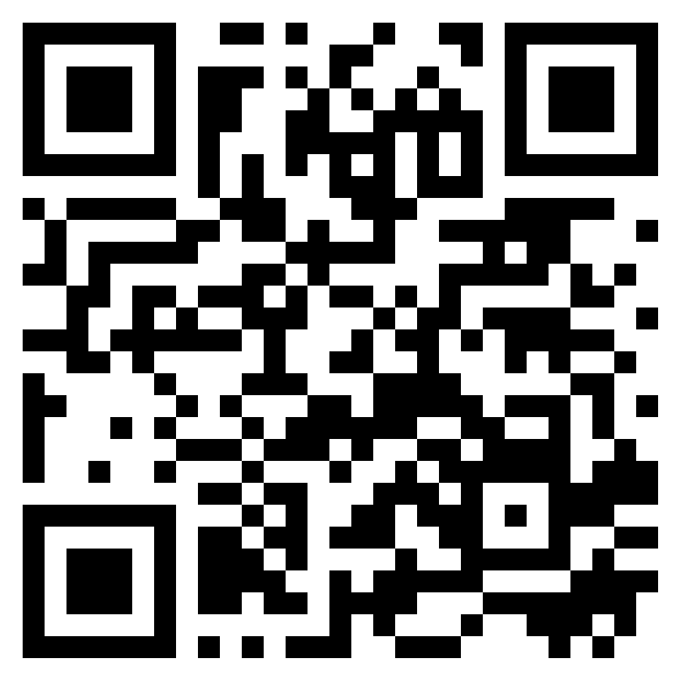
adamborecki.github.io/mixcube/
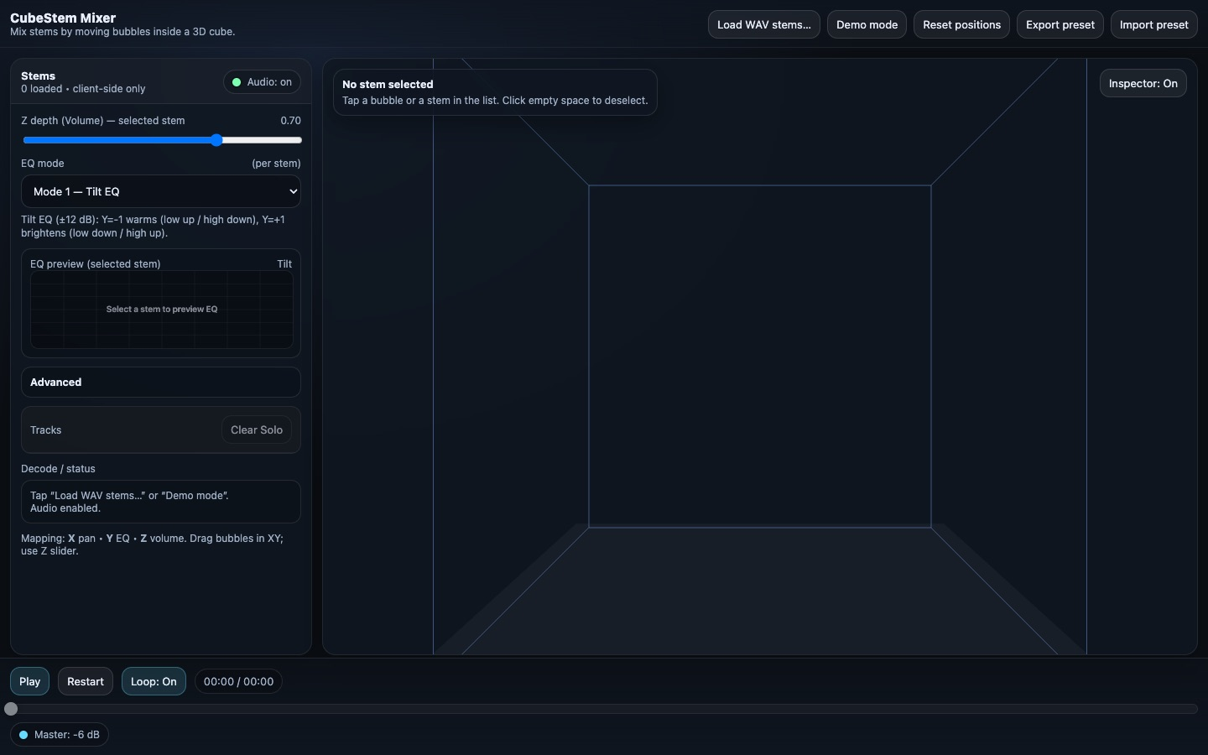
A 3D-mixing analogy for stereo imaging, with a dynamics-processor add-on.
Inspired by David Gibson’s The Art of Mixing: each instrument is a bubble in a room, where left-right is pan, front-back is volume, and up-down is pitch.
Source code: github.com/adamborecki/mixcube

MUSIC TECHNOLOGY EDUCATION

Mid/Side Processing
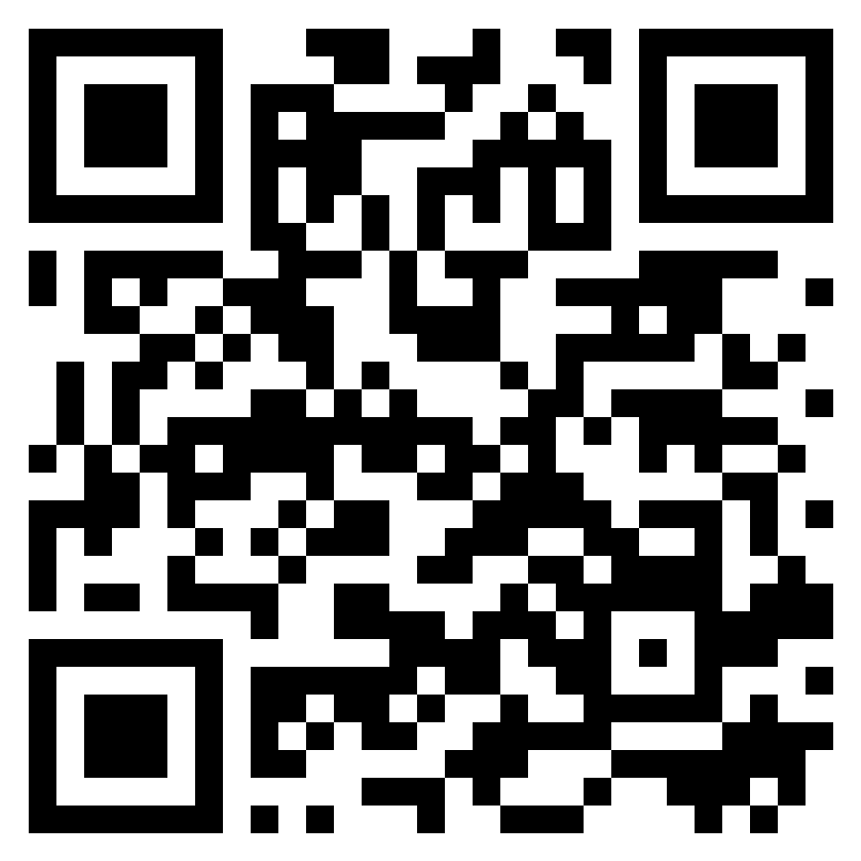
adamborecki.github.io/mid-side/
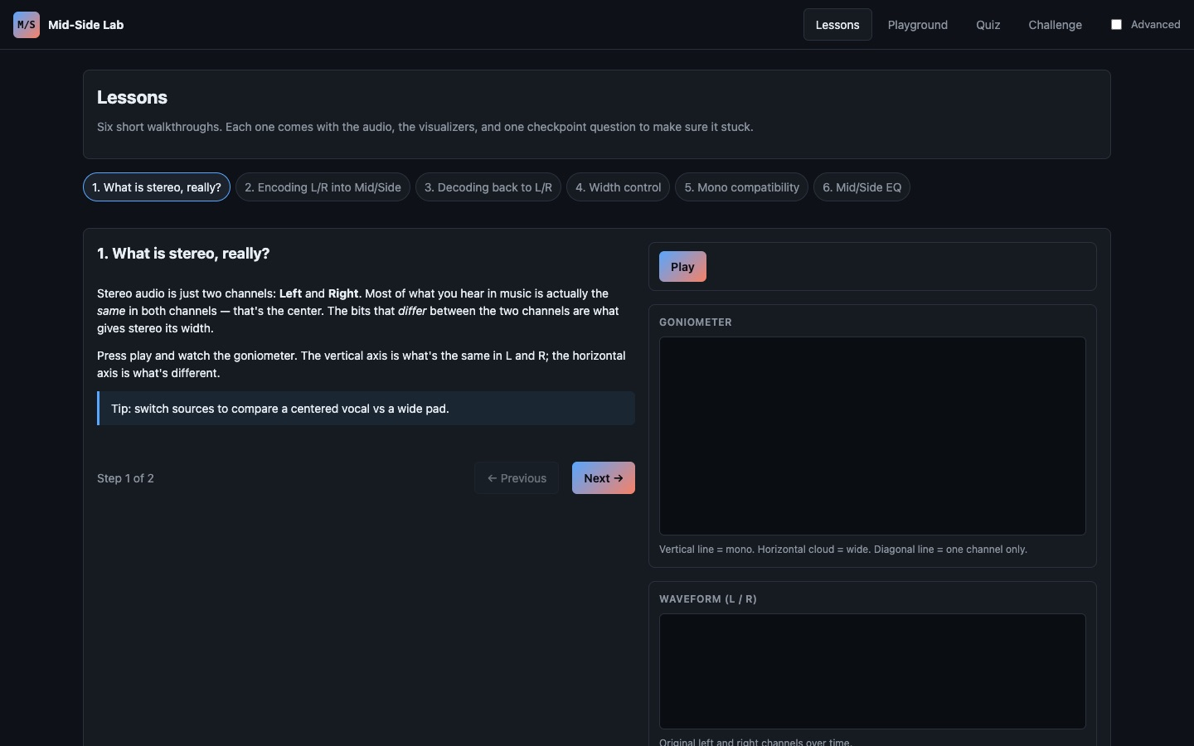
Lessons, a playground, and a quiz on mid/side encoding and stereo width.
Students hear the mid and side channels separately and see how width changes affect the stereo image.
Source code: github.com/adamborecki/mid-side

MUSIC TECHNOLOGY EDUCATION

Sidechain Compression
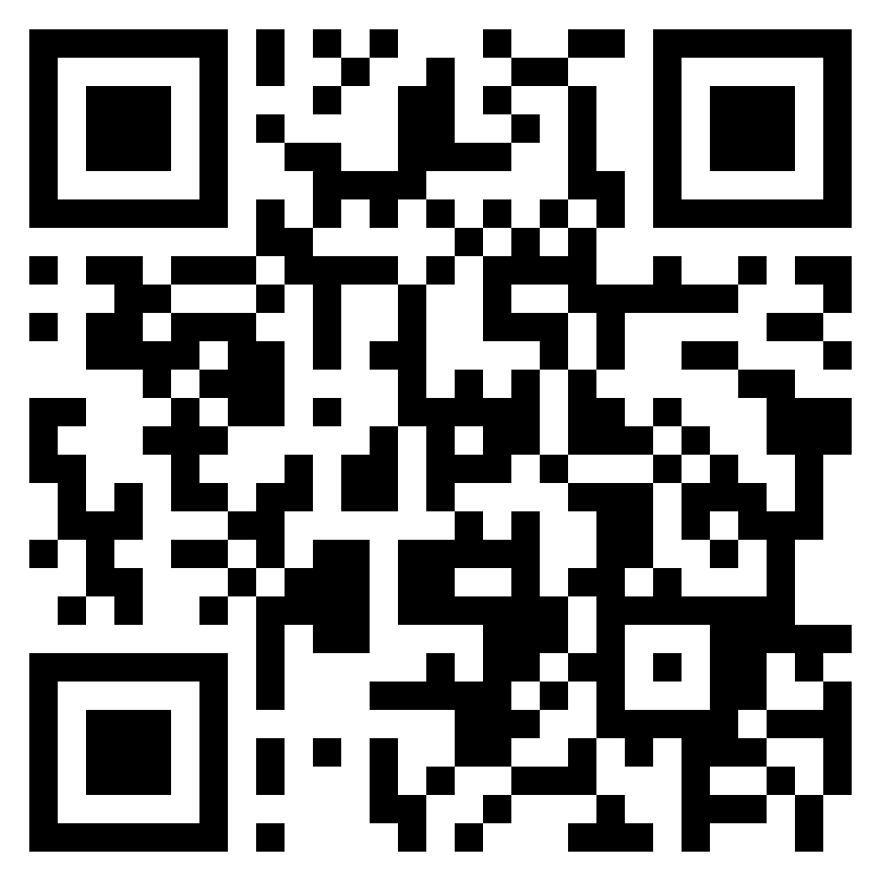
adamborecki.github.io/sidechain/
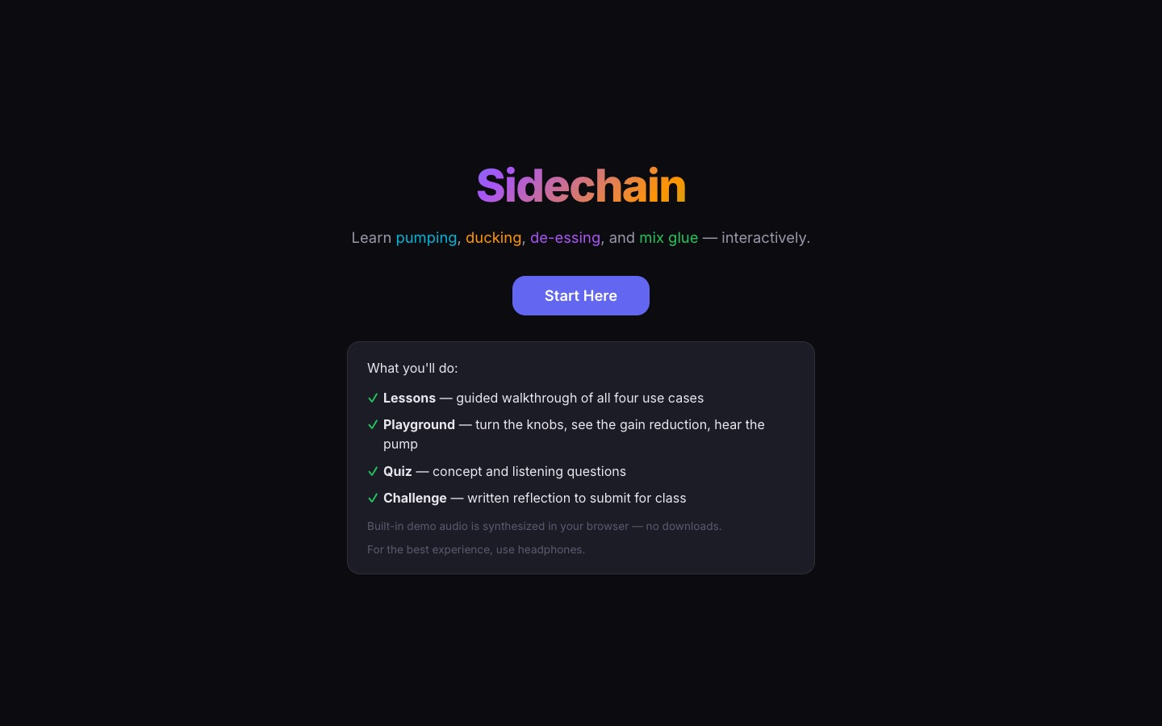
Learn pumping, ducking, de-essing, and mix glue, interactively.
Guided lessons, a playground for gain reduction, a quiz, and a written reflection challenge students submit for class.
Source code: github.com/adamborecki/sidechain

MUSIC TECHNOLOGY EDUCATION

Multiband Dynamics
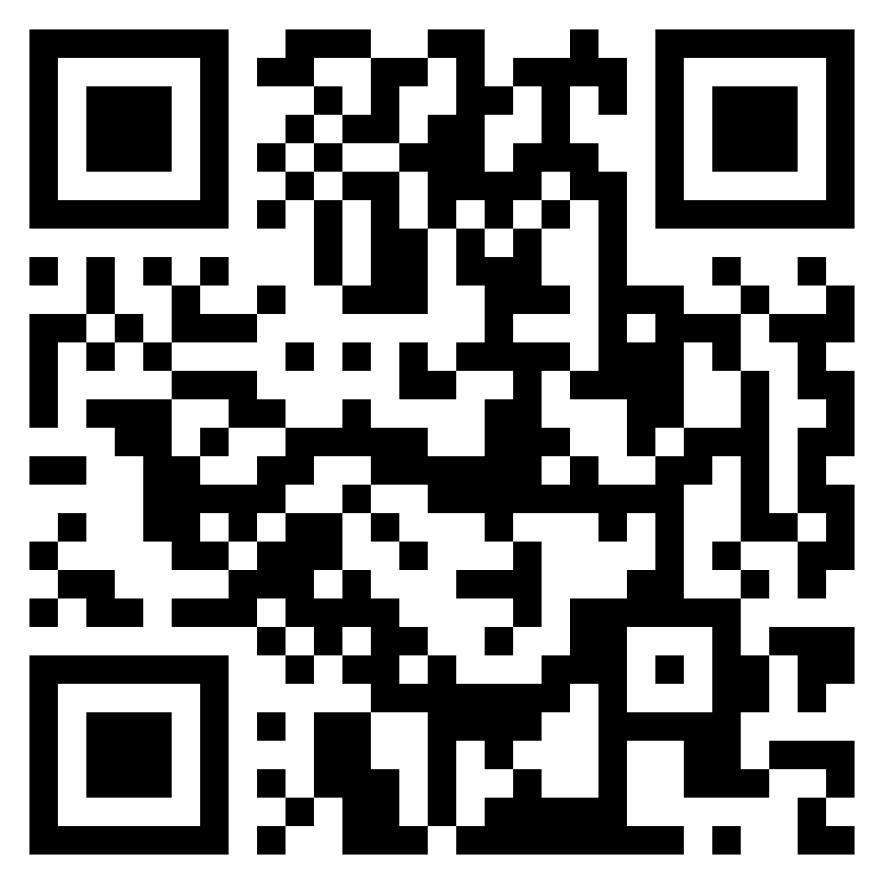
adamborecki.github.io/multiband/
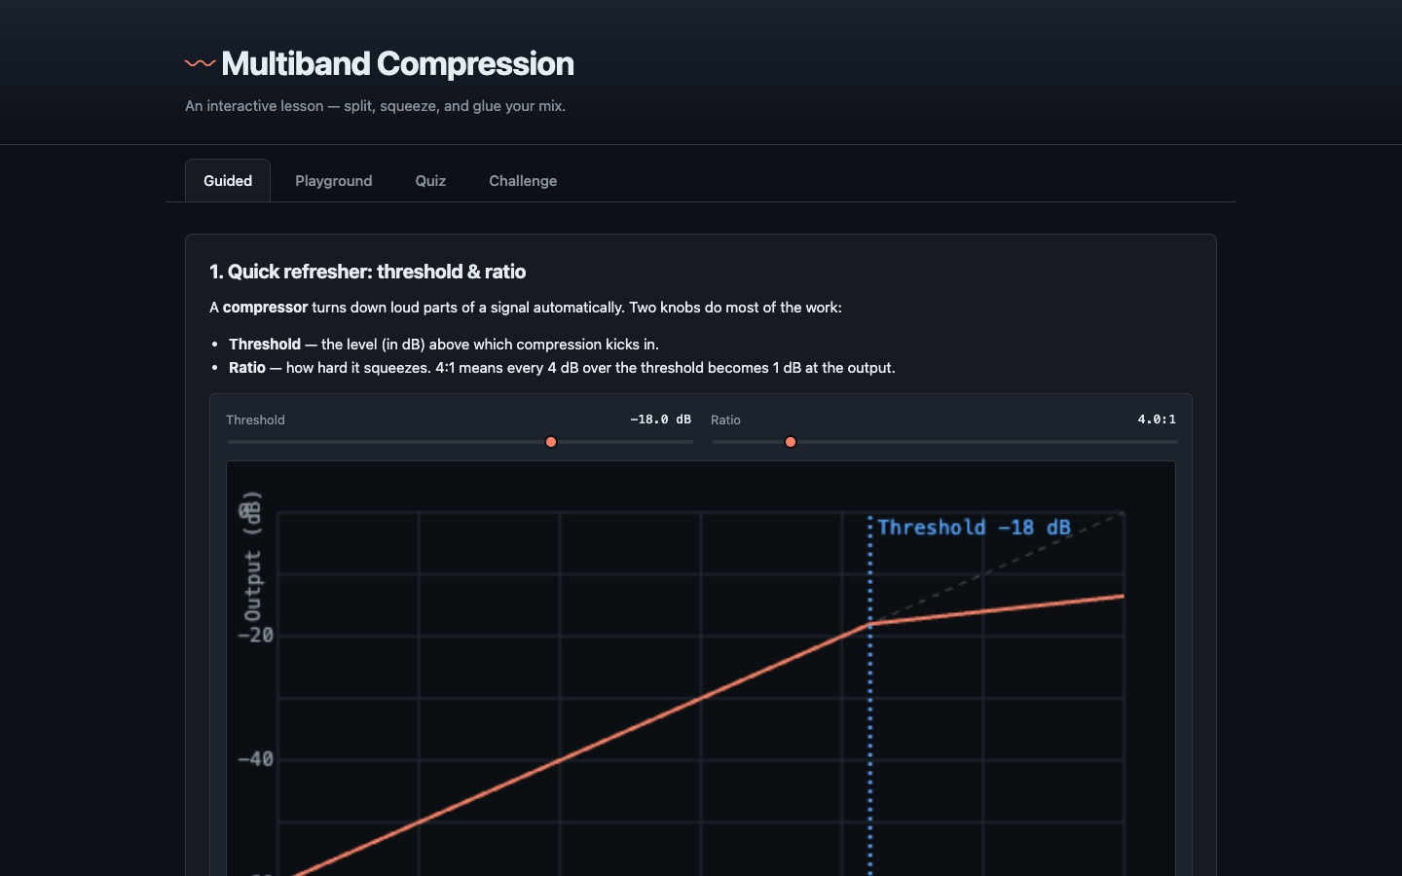
An interactive lesson on splitting, squeezing, and gluing a mix by frequency band.
Threshold and ratio are shown on a live transfer curve, then applied separately to each band of the spectrum.
Source code: github.com/adamborecki/multiband

MUSIC TECHNOLOGY EDUCATION

Multiband Mayhem
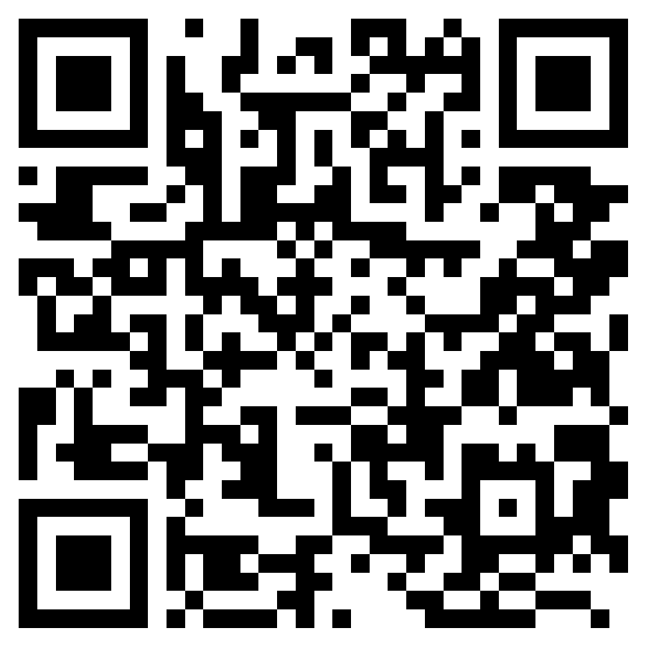
adamborecki.github.io/multiband-game/
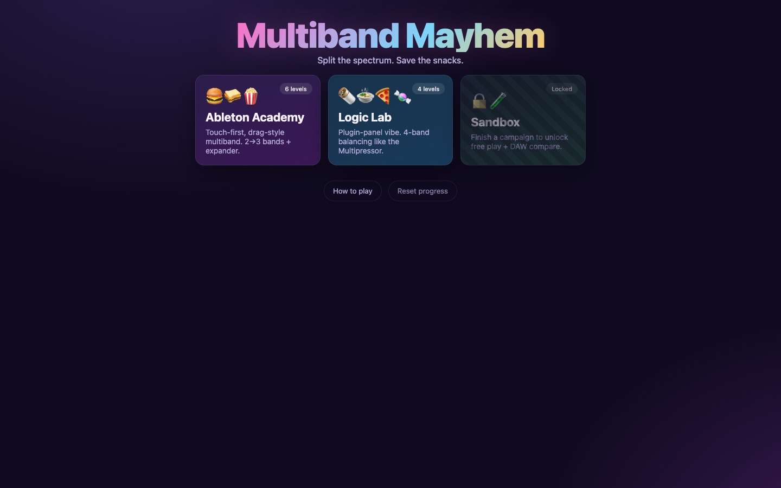
The game version of multiband compression: split the spectrum, save the snacks.
A playful companion to the Multiband Dynamics lesson, for practicing the same ideas under a little time pressure.
Source code: github.com/adamborecki/multiband-game

MUSIC TECHNOLOGY EDUCATION

Harmonic Series Builder: Prototype Archive
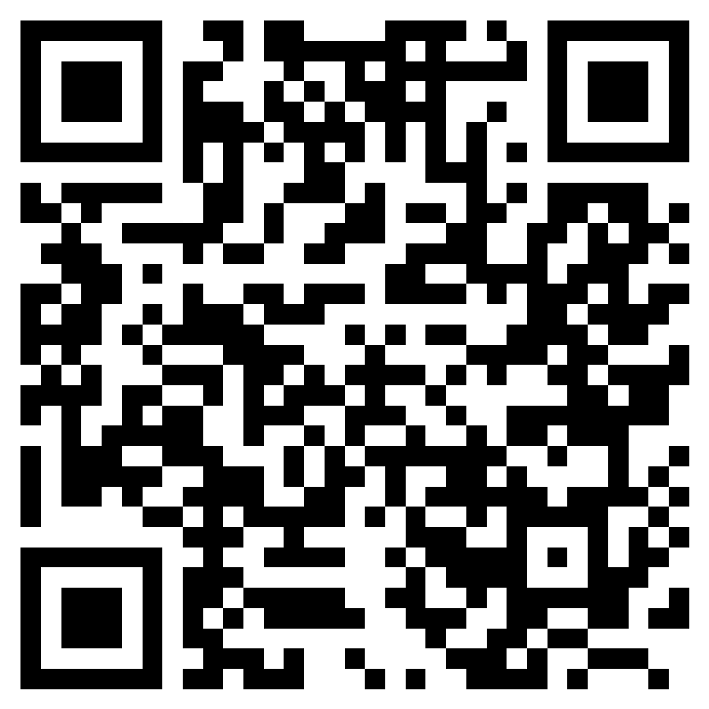
adamborecki.github.io/harmonic-series-builder/
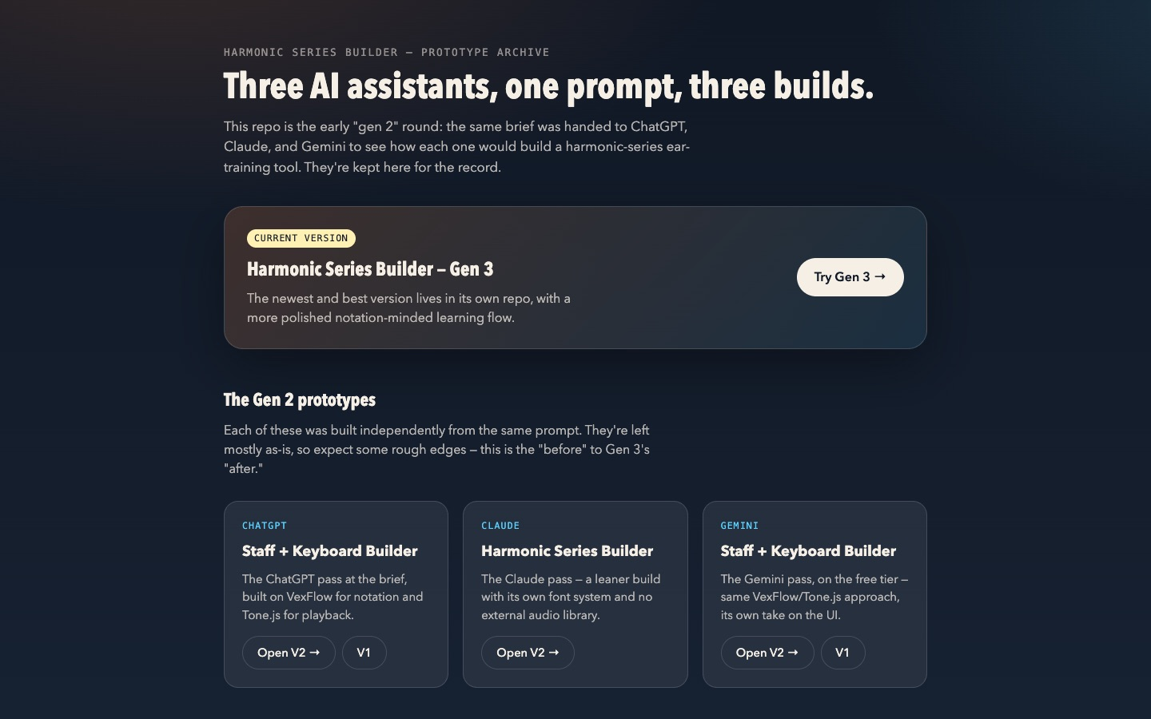
Three early builds of the harmonic-series trainer: one prompt, handed to three AI assistants.
Kept as a record of the process. The same brief went to ChatGPT, Claude, and Gemini, and the results are compared side by side. Superseded by the Gen 3 builder.
Source code: github.com/adamborecki/harmonic-series-builder

INSTRUMENTS & EFFECTS

Sock Piano
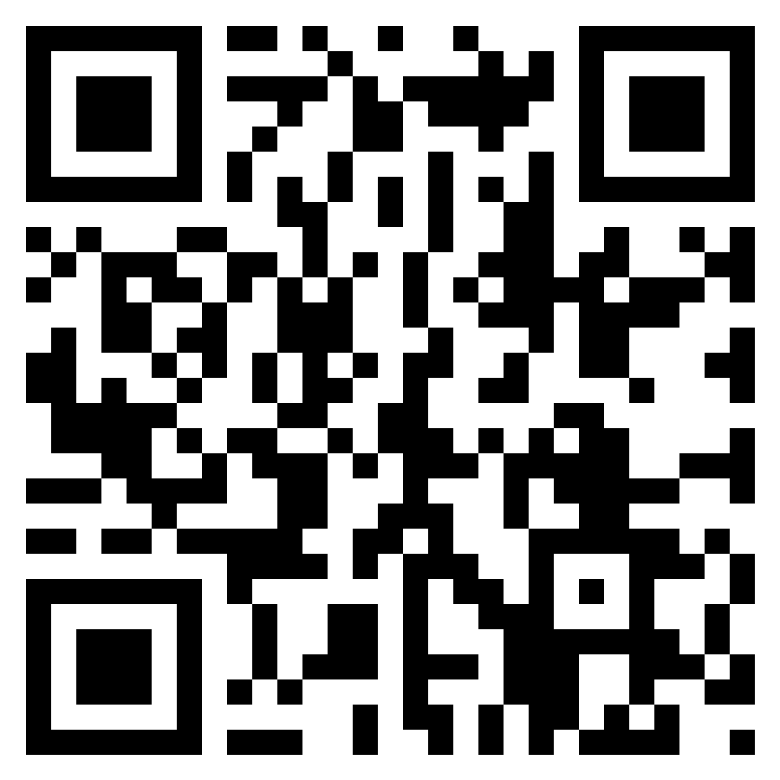
adamborecki.github.io/sock-piano/
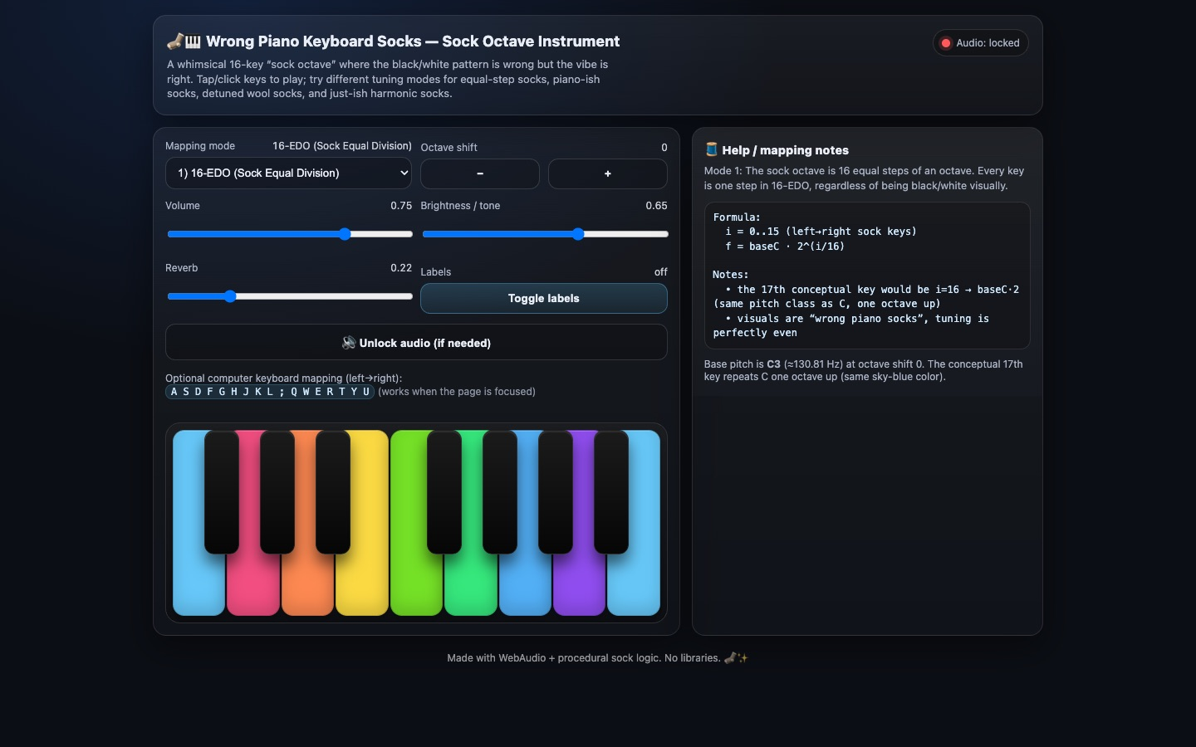
A playable instrument built on the "wrong" key pattern of a pair of rainbow piano socks.
A joke that became a tuning experiment: the socks’ black-key pattern doesn’t match a real piano, so the app asks what scale they would play if they did.
Source code: github.com/adamborecki/sock-piano

INSTRUMENTS & EFFECTS

Uke Chord Buddy
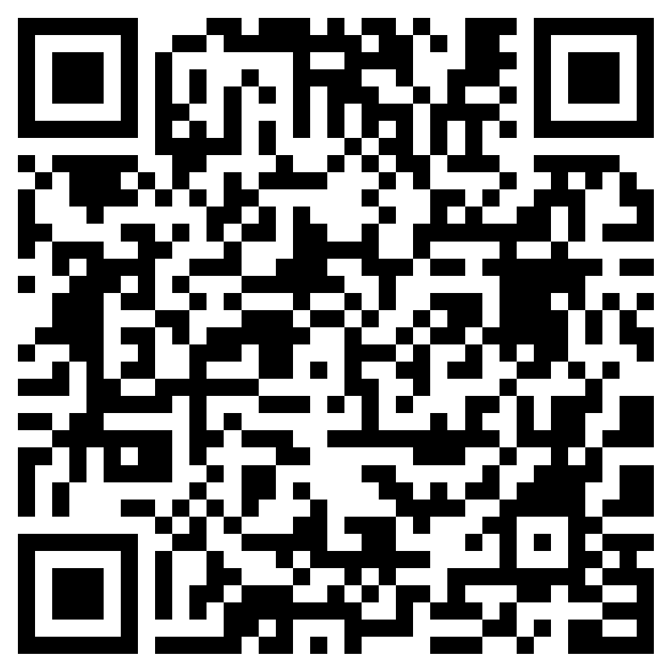
adamborecki.github.io/misc-music-webapps/uke_chord_buddy.html
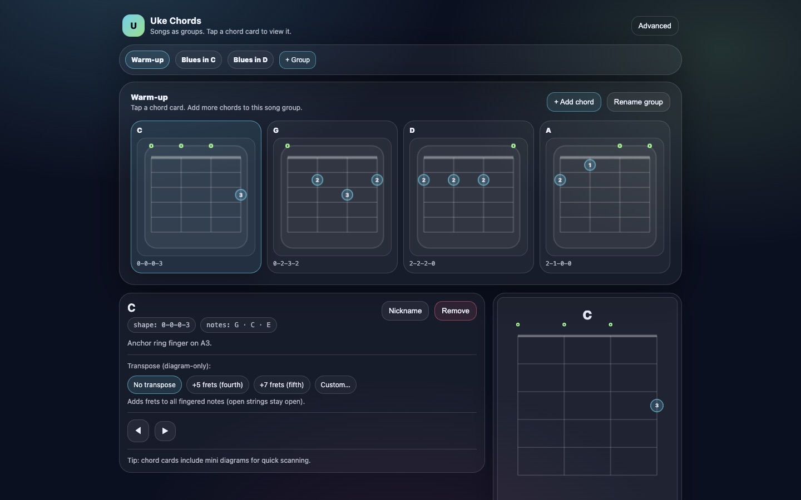
A ukulele chord reference, grouped by song, for quick lookup while playing.
Built to sit on a music stand: big chord diagrams, song-by-song sets, and transposition.
Source code: github.com/adamborecki/misc-music-webapps

INSTRUMENTS & EFFECTS

Me Again
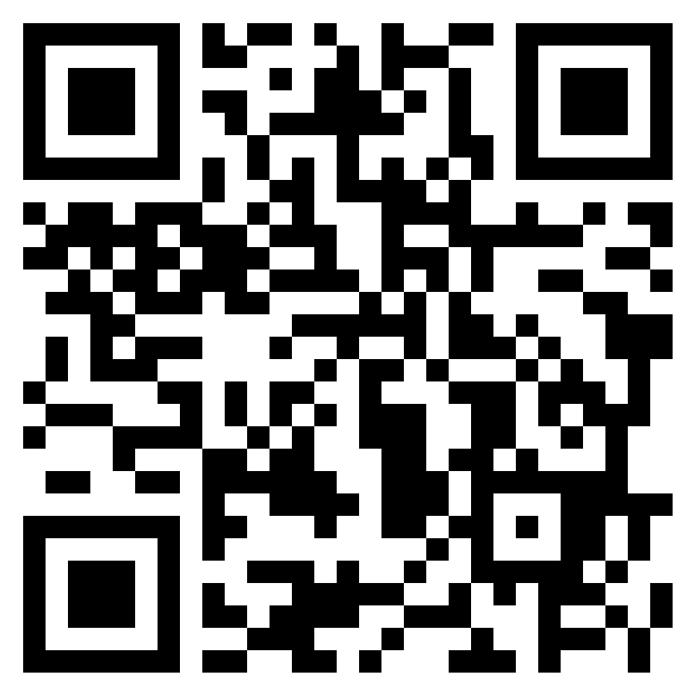
adamborecki.github.io/me-again/
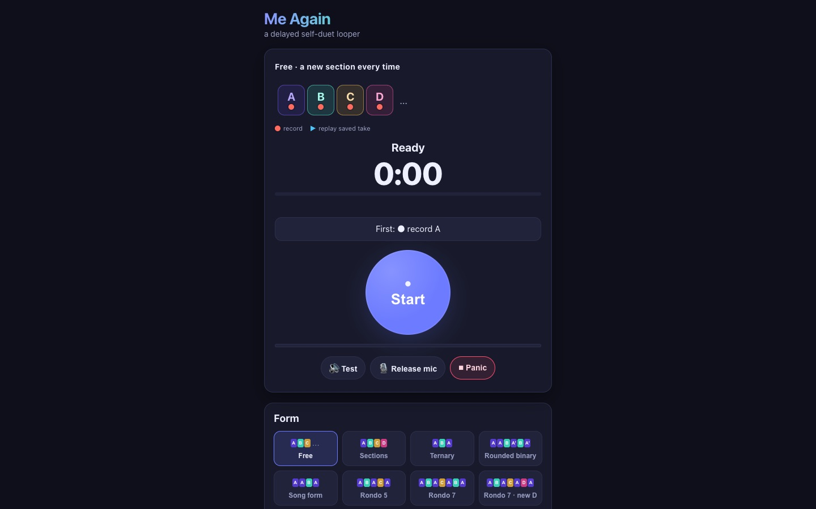
A delay looper for improvising duets with a slightly earlier version of yourself.
Built for phones. Play a phrase, and it comes back a few seconds later for you to answer.
Source code: github.com/adamborecki/me-again

INSTRUMENTS & EFFECTS

There and Back Again
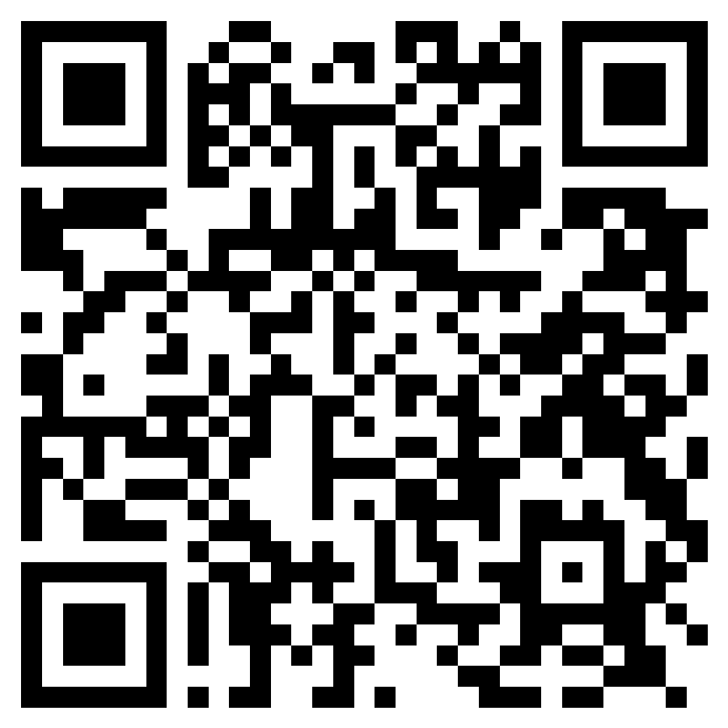
adamborecki.github.io/there-and-back/
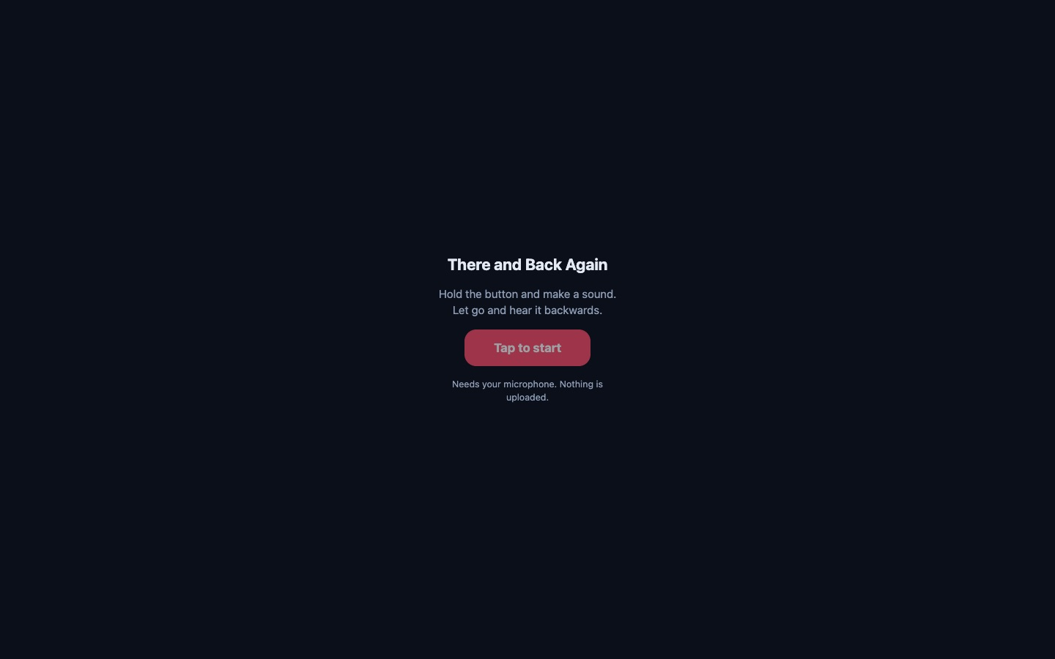
Hold to record, let go to hear it backwards.
A reverse-audio toy for the phone browser, with up to three layered tracks and WAV export. Nothing is uploaded; it runs entirely in the browser.
Source code: github.com/adamborecki/there-and-back

INSTRUMENTS & EFFECTS

Misc Music Webapps
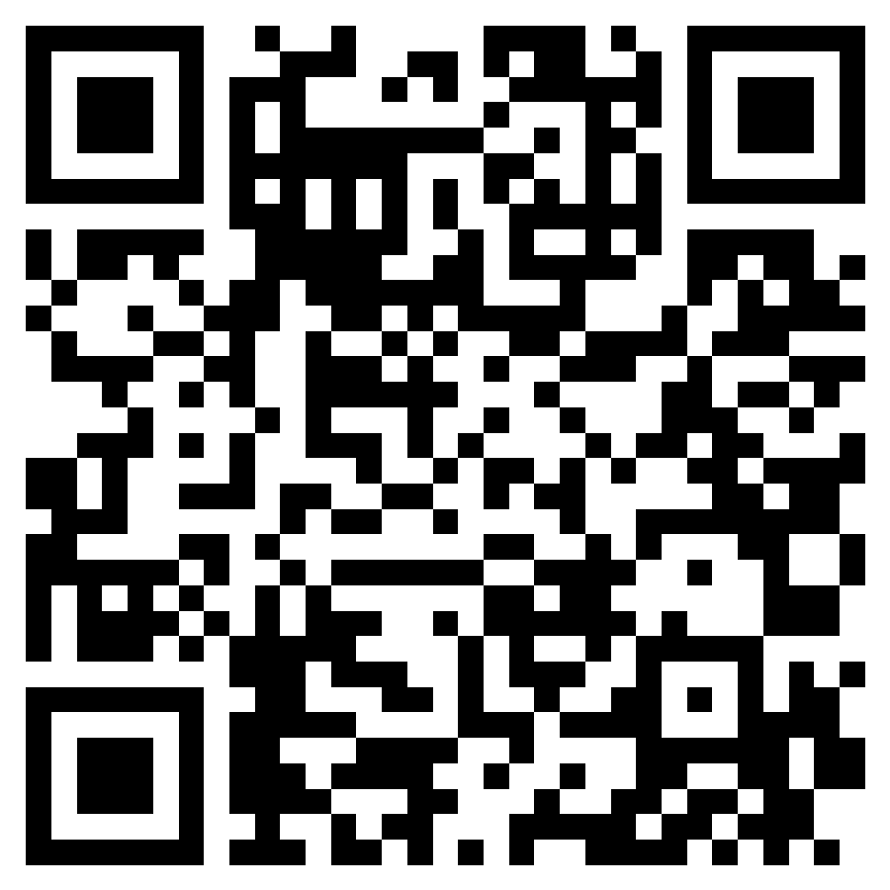
adamborecki.github.io/misc-music-webapps/
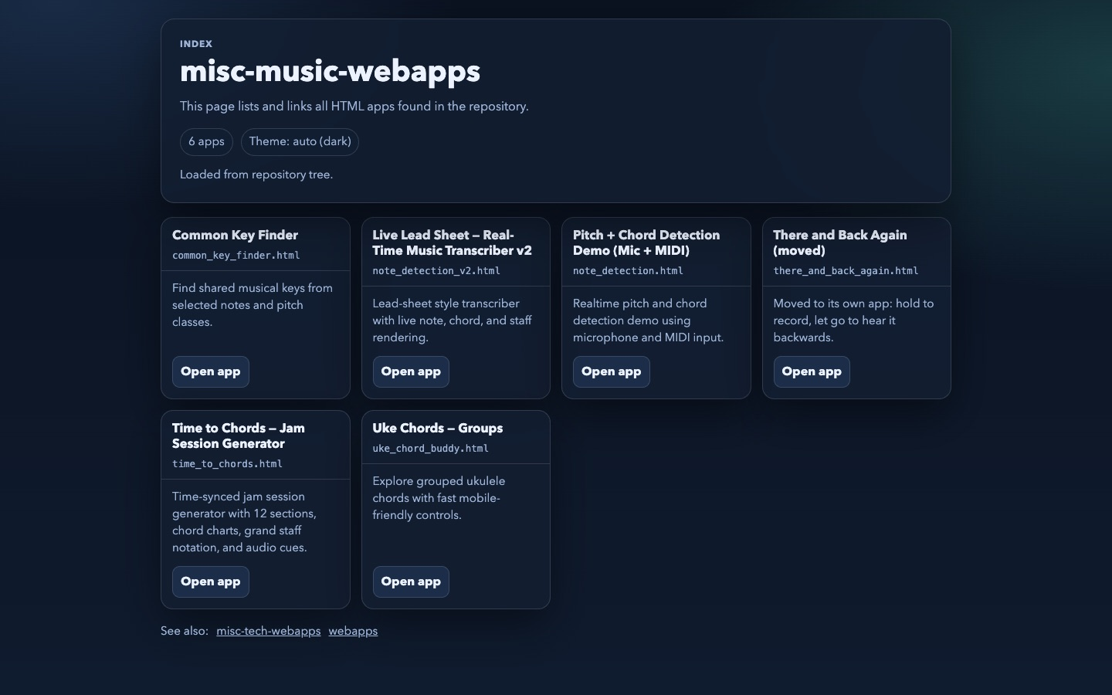
The full collection: key finder, chord tools, note detection, jam-session generators, and more.
A grab bag of small single-file music tools, each one a quick answer to a real practice-room question.
Source code: github.com/adamborecki/misc-music-webapps

MULTI-DISCIPLINE EDUCATION

Camera Lab
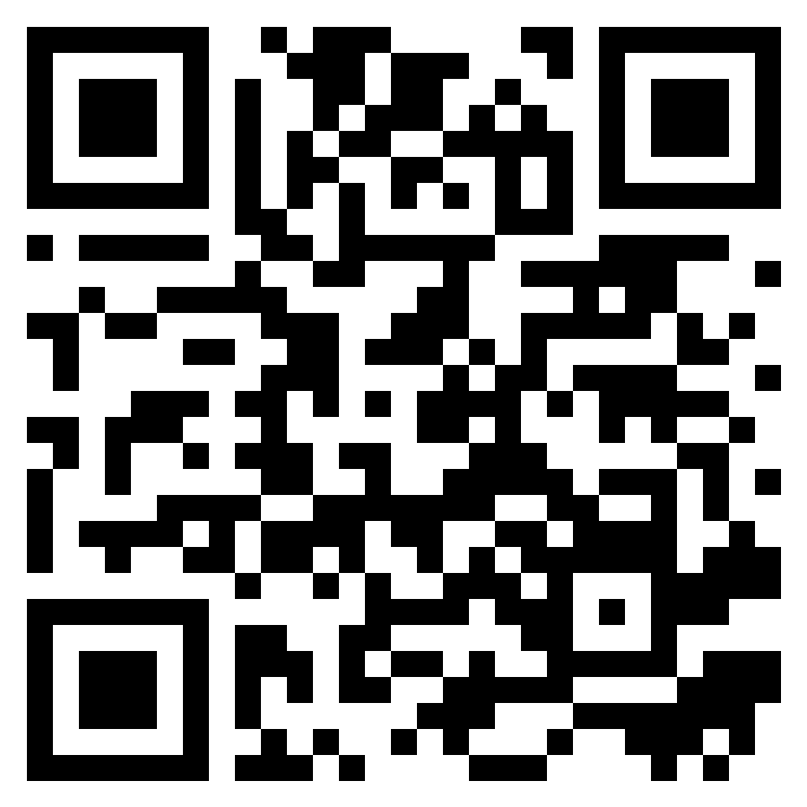
adamborecki.github.io/camera-lab/
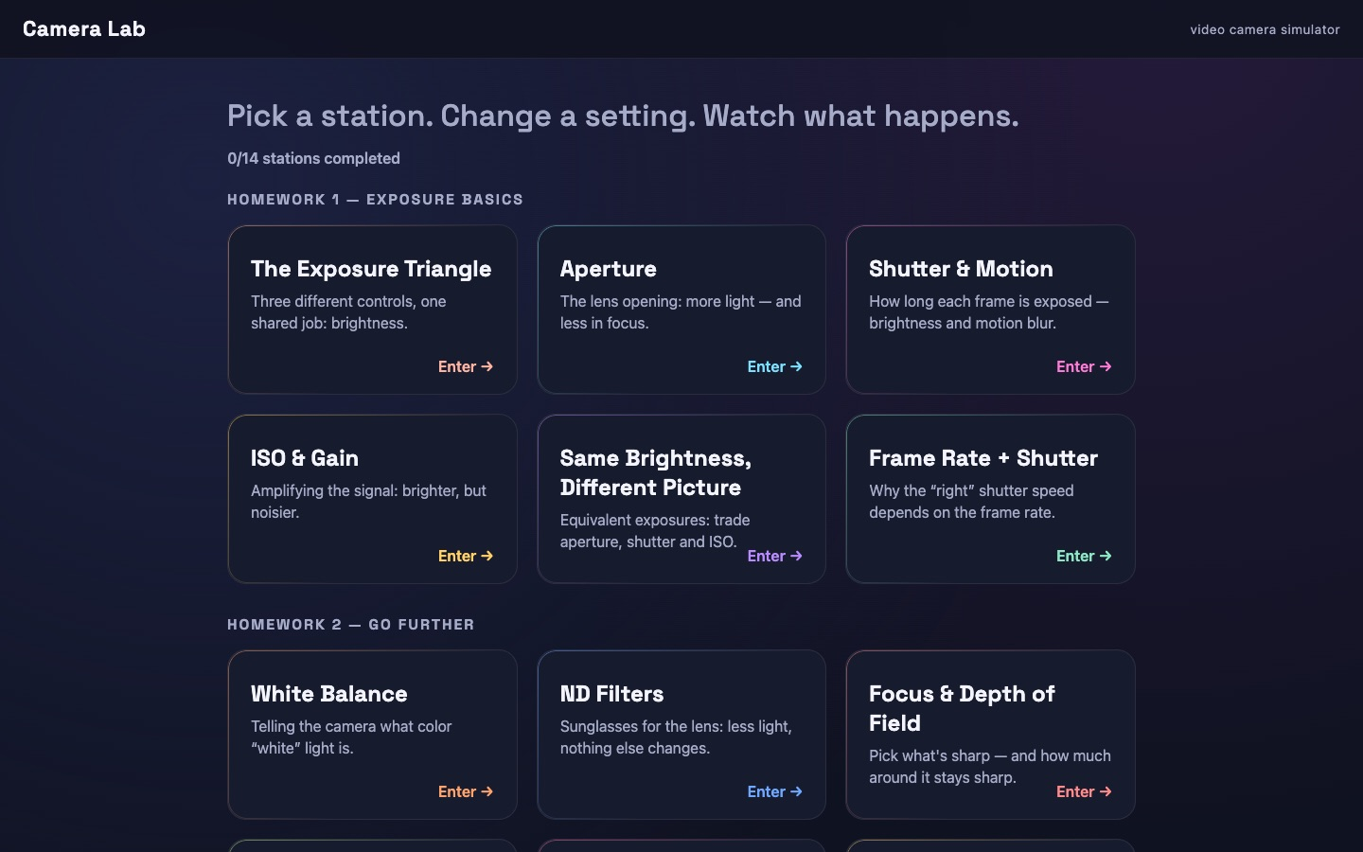
A hands-on video camera simulator for learning exposure, motion, focus, and color.
The sibling of Sound Lab. Students change aperture, shutter, ISO, ND, white balance, and focus on simulated scenes and see physically modeled results: depth of field, motion blur, noise, and clipping.
Source code: github.com/adamborecki/camera-lab

MULTI-DISCIPLINE EDUCATION

MUS 248 Activities
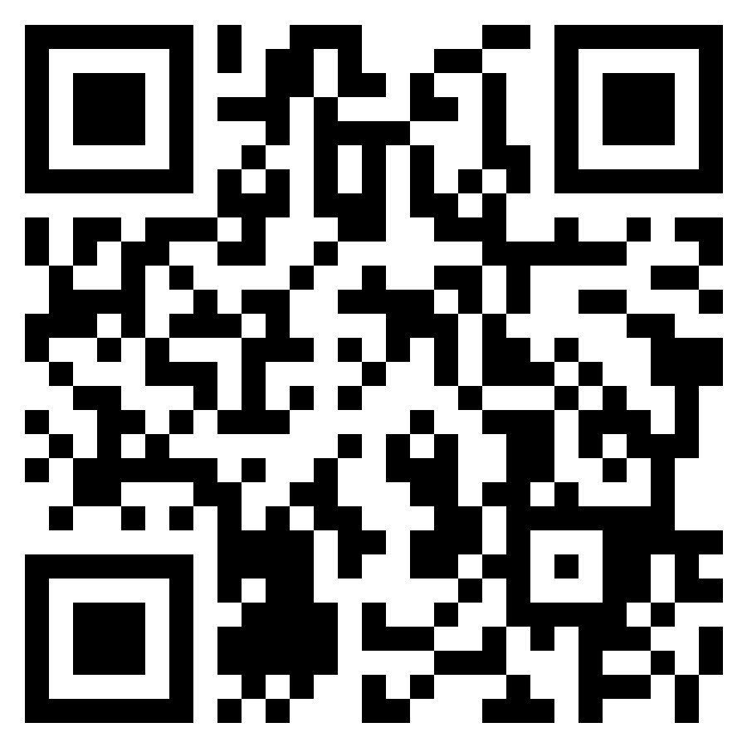
adamborecki.github.io/mus248/
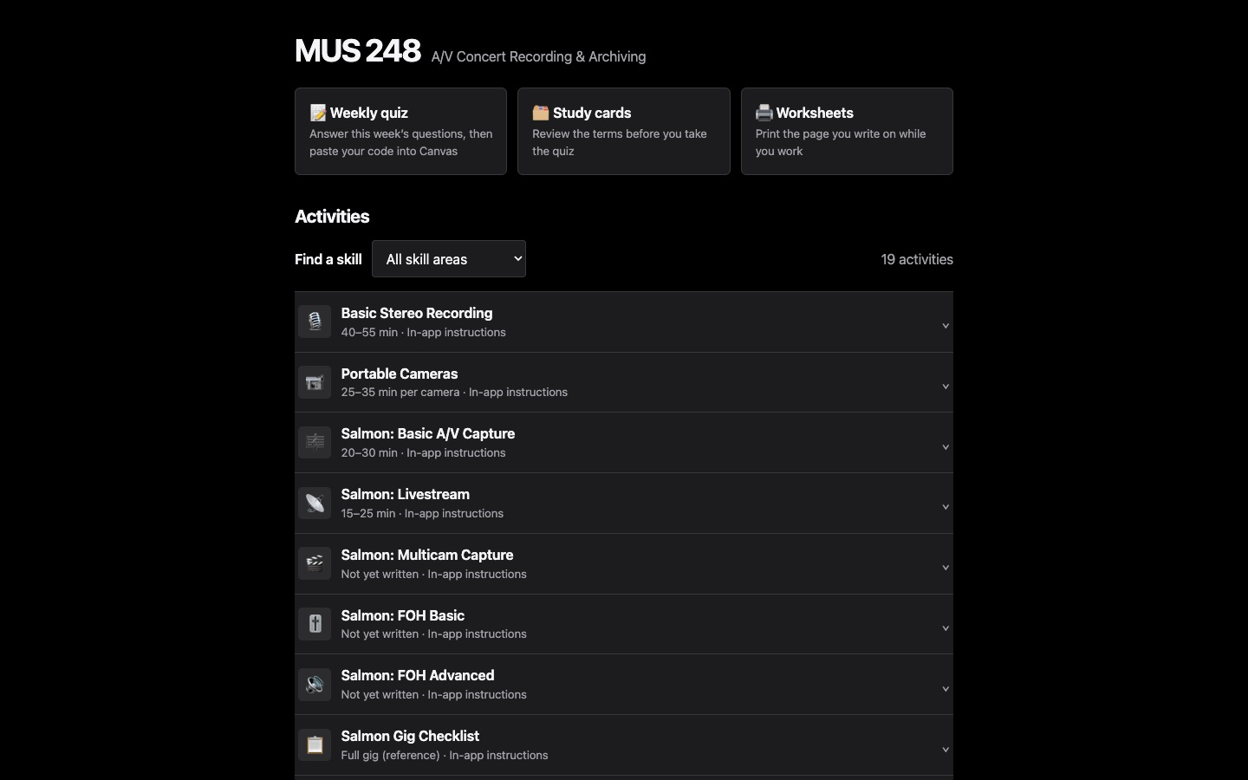
The activity hub for MUS 248, A/V Concert Recording & Archiving.
Weekly quizzes, study cards, printable worksheets, and step-by-step hands-on activities, from stereo mic technique and the X32 console to Dante networking and multicam capture.
Source code: github.com/adamborecki/mus248

MULTI-DISCIPLINE EDUCATION

Sight Reading
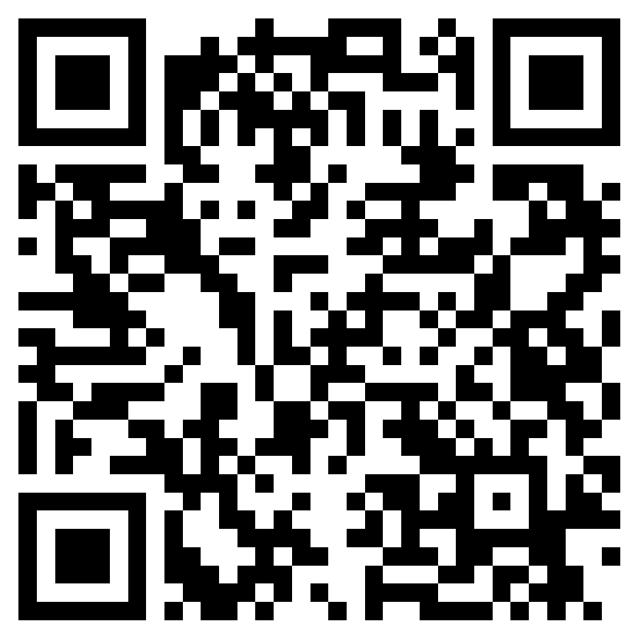
adamborecki.github.io/sight-reading/
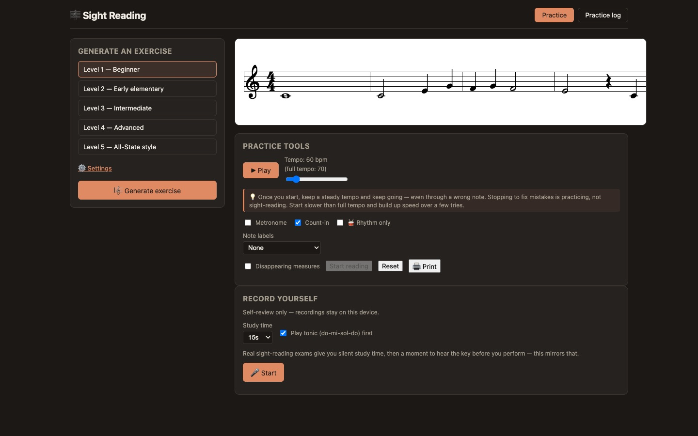
A sight-reading and sight-singing generator that writes new notation on demand.
Rather than a fixed question bank, it composes new exercises from difficulty settings, plays them back with a metronome, and lets students record themselves to review.
Source code: github.com/adamborecki/sight-reading

MULTI-DISCIPLINE EDUCATION

Instruments
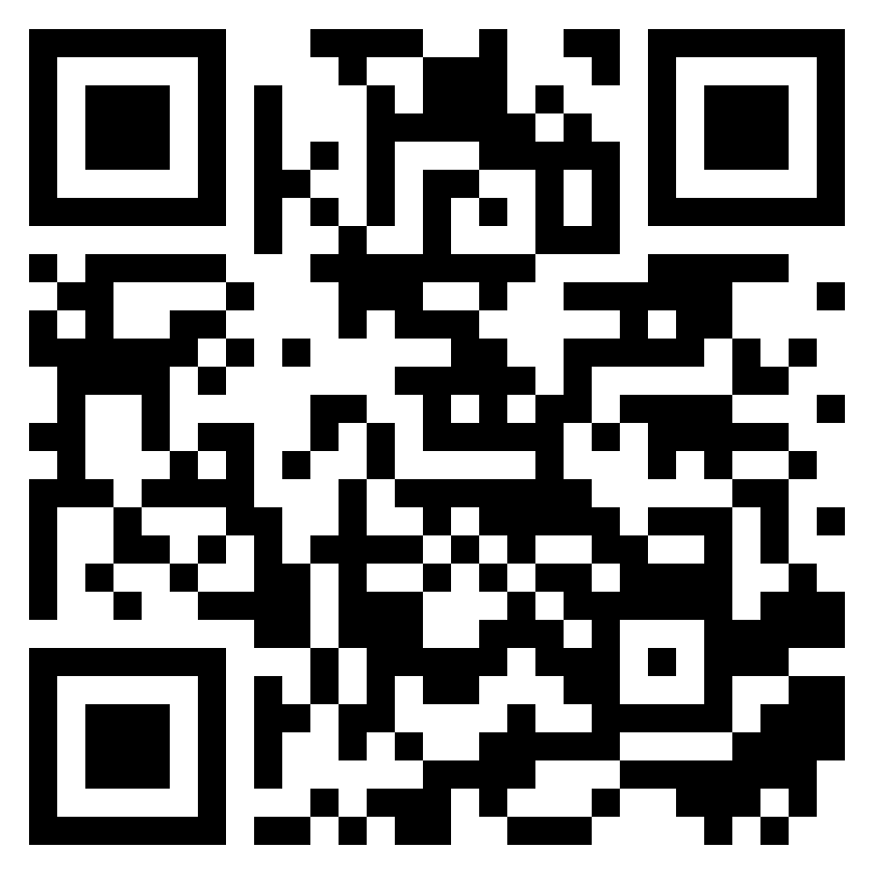
adamborecki.github.io/instruments/
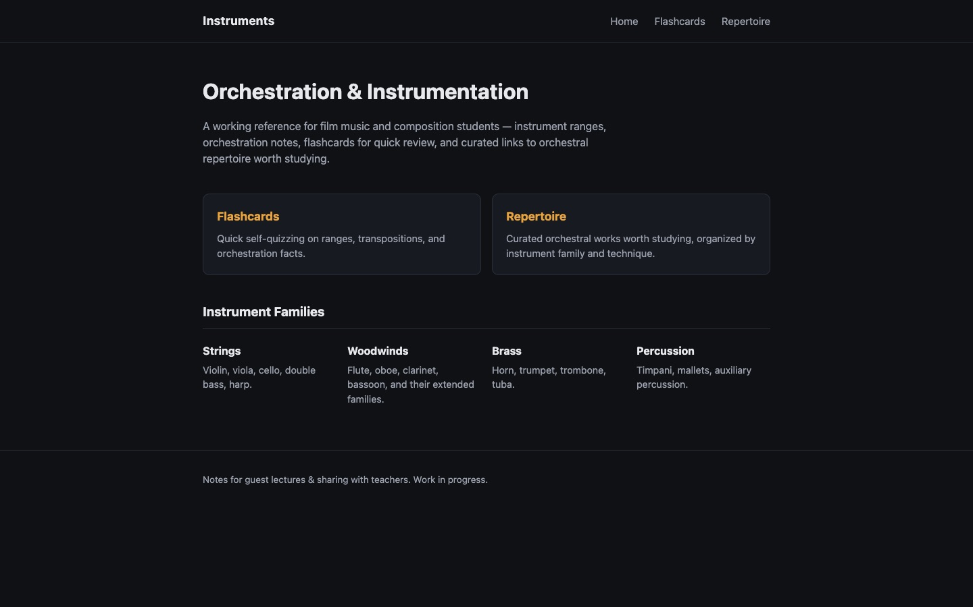
An orchestration and instrumentation reference for film-music and composition students.
Instrument ranges and orchestration notes, flashcards for quick self-quizzing, and curated repertoire organized by instrument family.
Source code: github.com/adamborecki/instruments

MULTI-DISCIPLINE EDUCATION

Mahler’s First
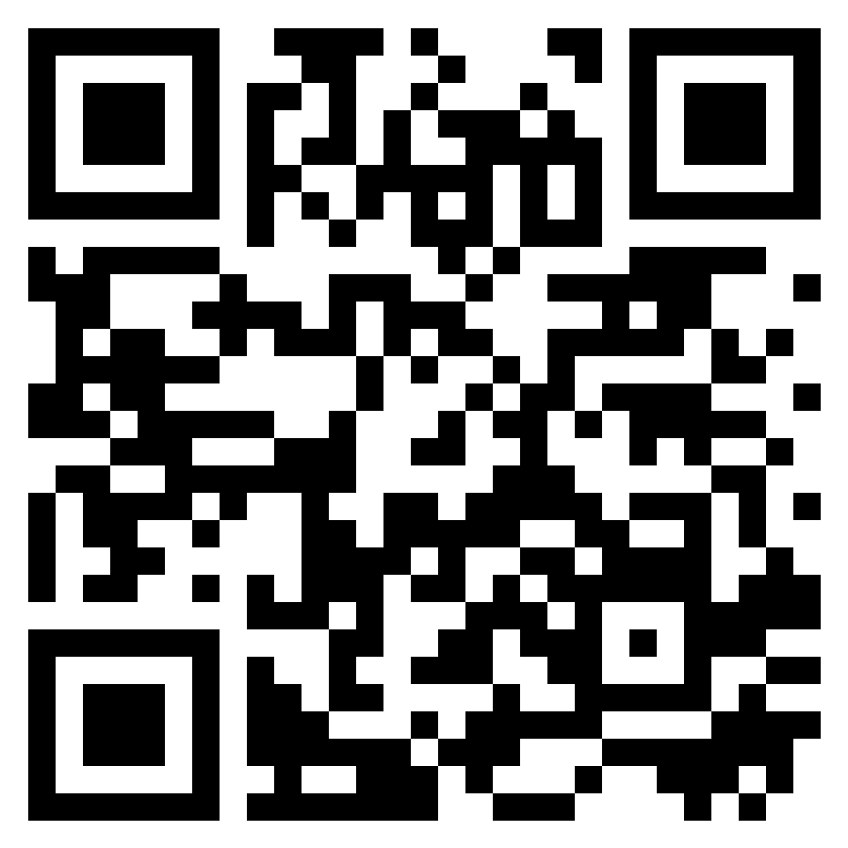
adamborecki.github.io/mahler1/
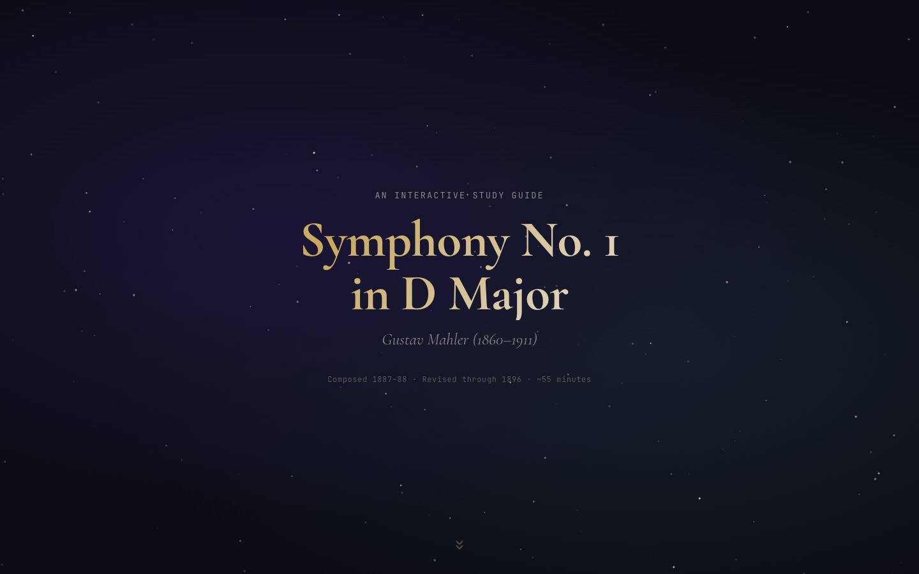
An interactive study guide to Mahler’s Symphony No. 1, movement by movement.
A listening companion that walks through themes, form, and context alongside the recording.
Source code: github.com/adamborecki/mahler1

MULTI-DISCIPLINE EDUCATION

Turangalîla
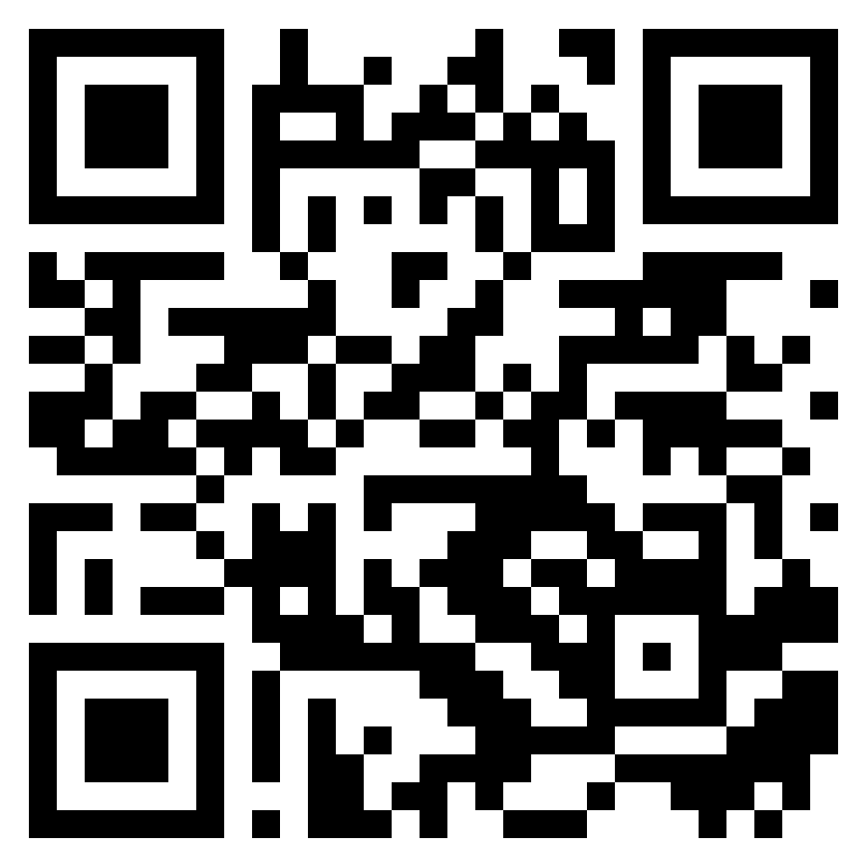
adamborecki.github.io/turangalila/
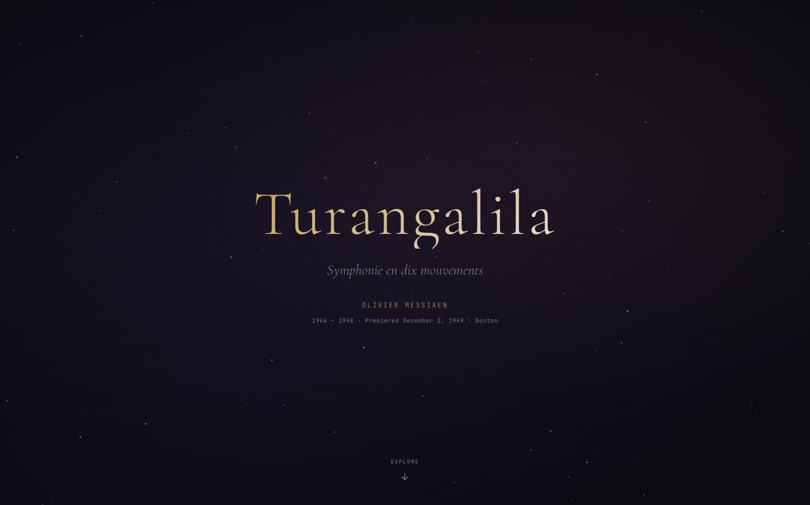
An interactive listener’s guide to Messiaen’s Turangalîla-Symphonie.
Ten movements, cyclic themes, and the ondes Martenot, laid out so a first-time listener can follow along.
Source code: github.com/adamborecki/turangalila

MULTI-DISCIPLINE EDUCATION

Turandot: The Video Game
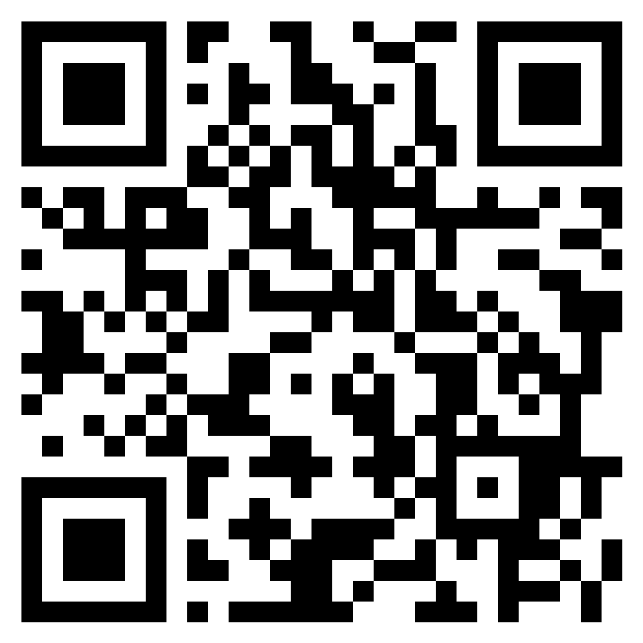
adamborecki.github.io/turandot/
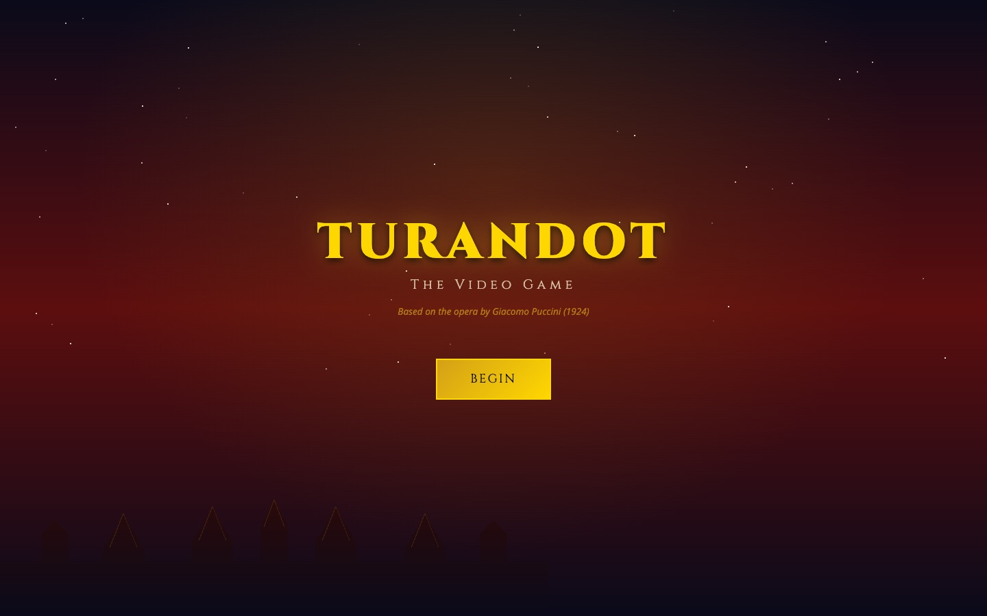
An interactive journey through Puccini’s unfinished opera: riddles, arias, and the story behind it.
Opera as a game: players answer Turandot’s riddles and move through the plot, with the music and its history as the reward.
Source code: github.com/adamborecki/turandot

MULTI-DISCIPLINE EDUCATION

8 Tiny Japanese Habits
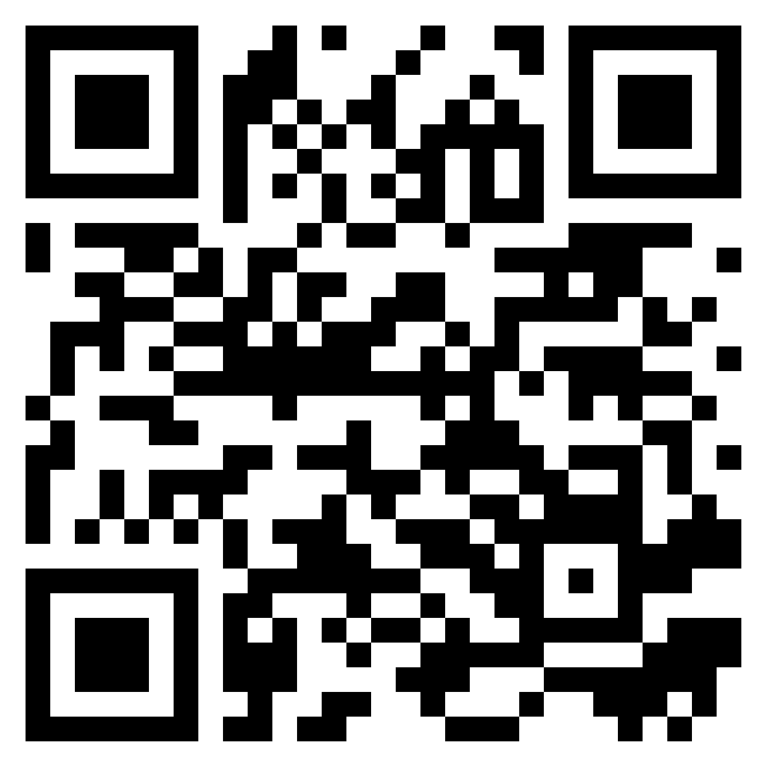
adamborecki.github.io/from-japan/
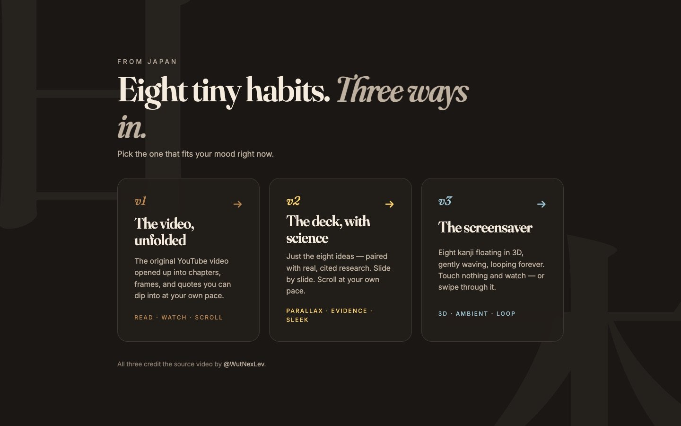
One YouTube video, rebuilt three ways: an unfolded video, a slide deck, and an ambient screensaver.
An experiment in format: the same content as something to watch, something to present, and something to live with.
Source code: github.com/adamborecki/from-japan

MULTI-DISCIPLINE EDUCATION

Quiz
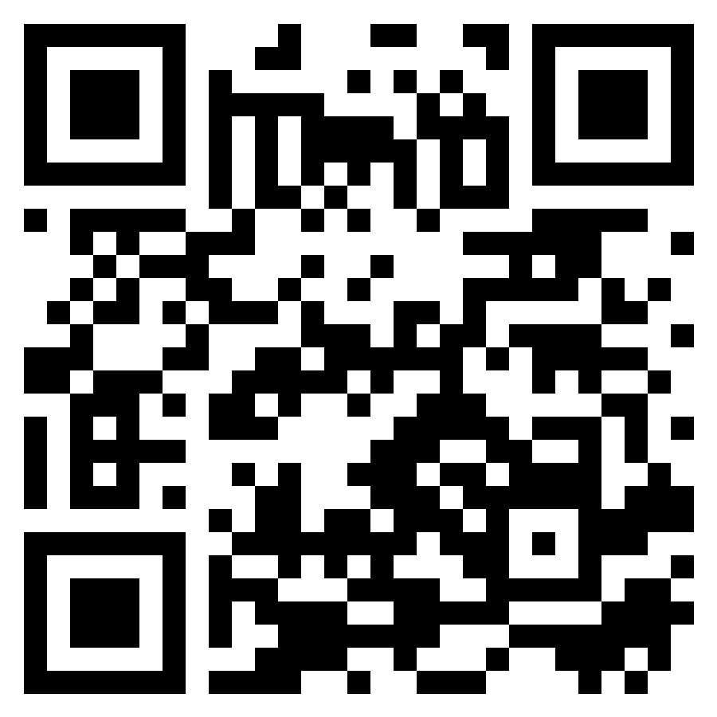
adamborecki.github.io/quiz/
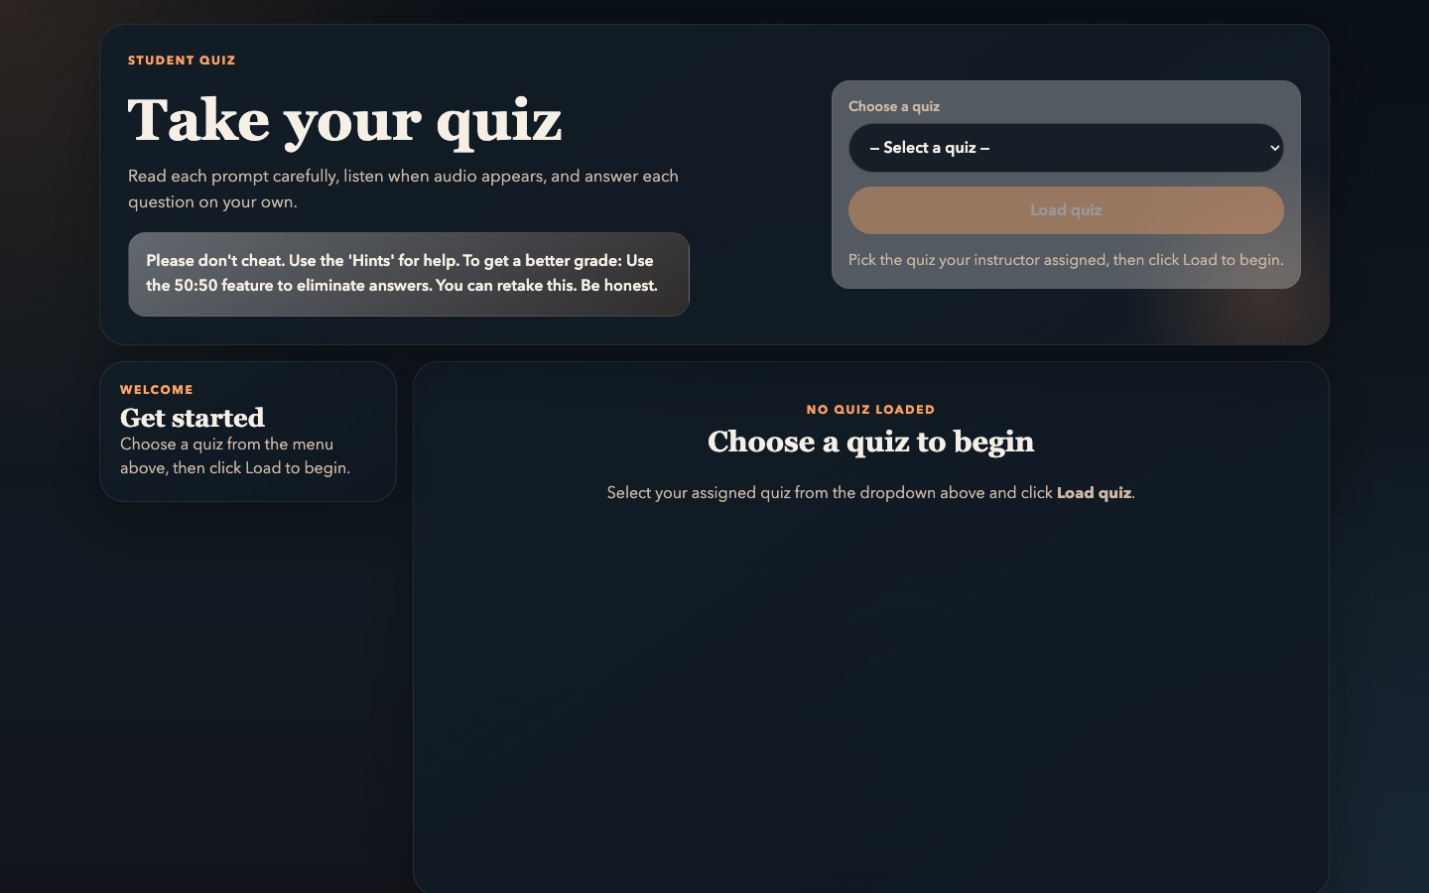
A cleaner quiz-taking tool built for Music Technology courses at Chapman University.
Students load an assigned quiz, answer audio and text questions, and paste a completion code into Canvas.
Source code: github.com/adamborecki/quiz

MULTI-DISCIPLINE EDUCATION

Note Detection
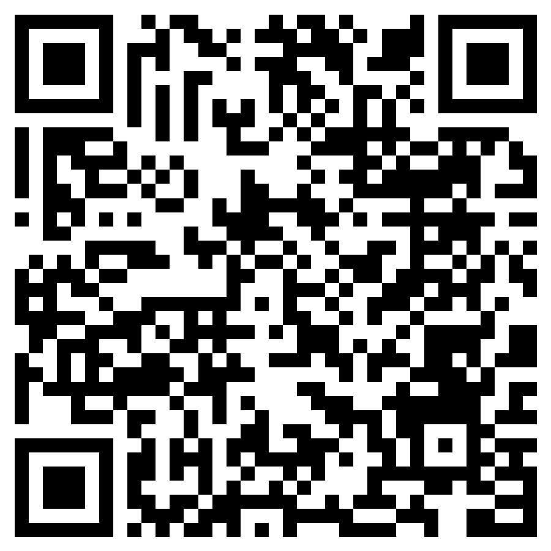
adamborecki.github.io/misc-music-webapps/note_detection_v2.html
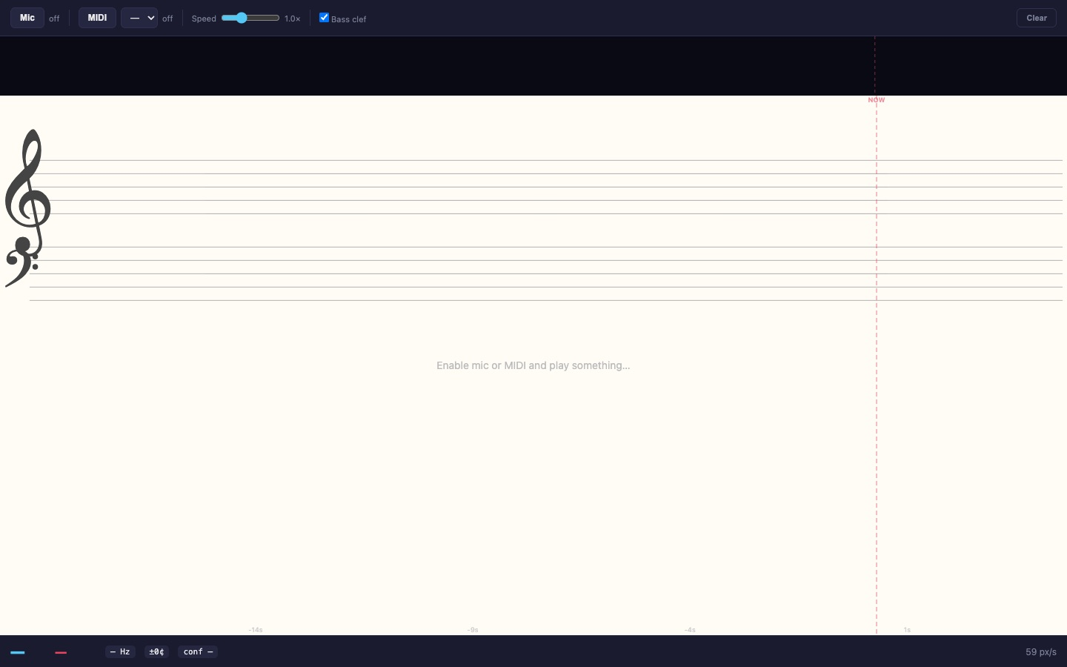
A real-time note detector and lead-sheet transcriber, with a live spectrogram view.
Sing or play into the microphone and watch pitches land on a staff as you go.
Source code: github.com/adamborecki/misc-music-webapps

MULTI-DISCIPLINE EDUCATION

The Four Seasons
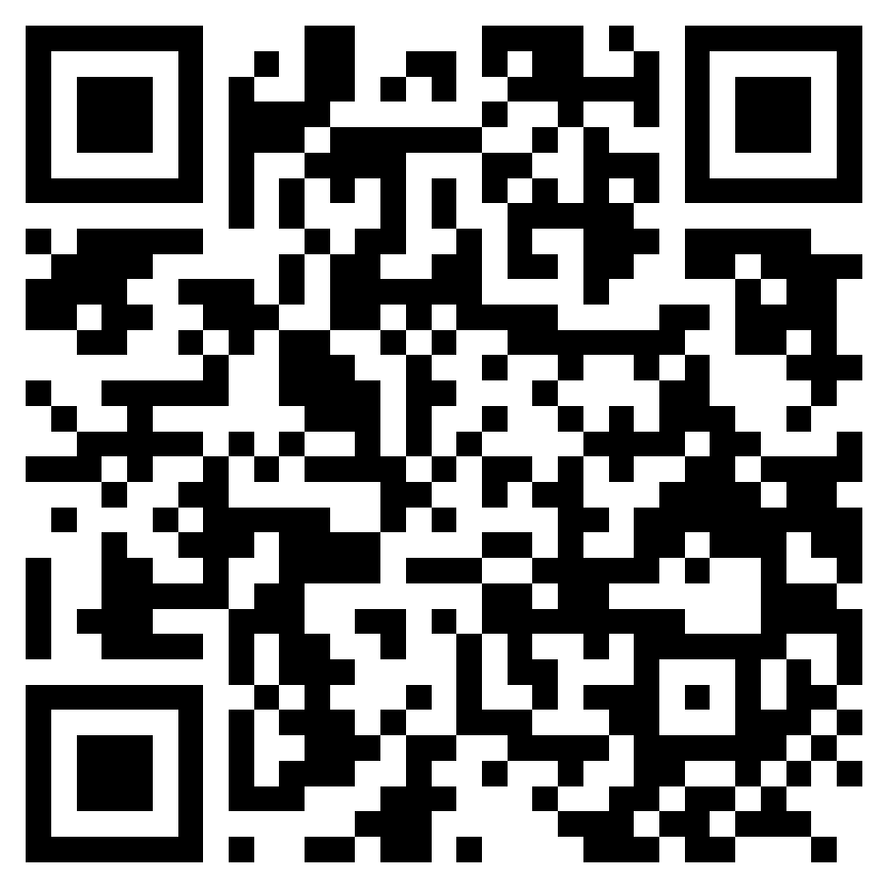
adamborecki.github.io/four-seasons/
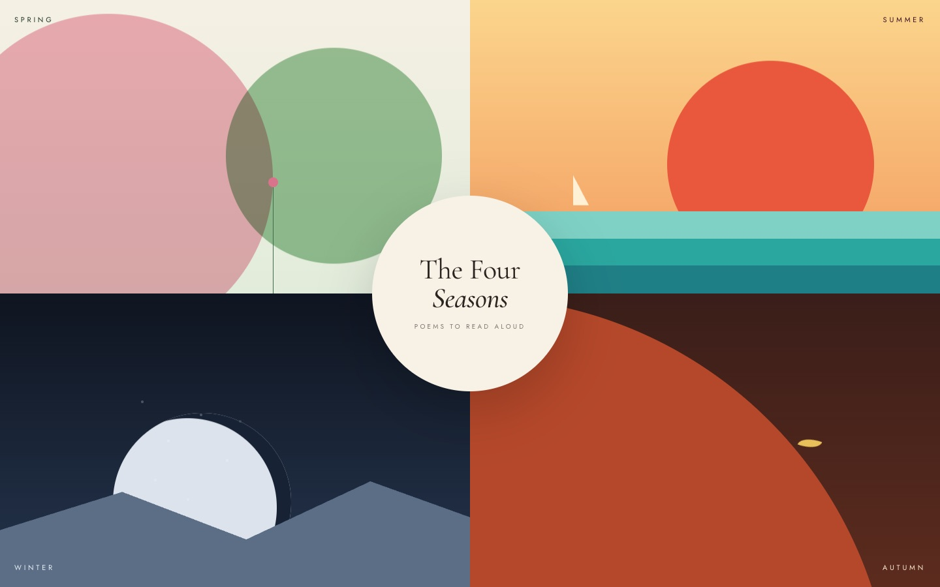
Poems of the four seasons to read aloud, with generative soundscapes and a voice instrument.
Read a poem aloud and the app answers in your pauses with what it just heard. Tap the sun or moon to start; double-tap an edge to change seasons.
Source code: github.com/adamborecki/four-seasons

PRACTICAL TOOLS

Gym
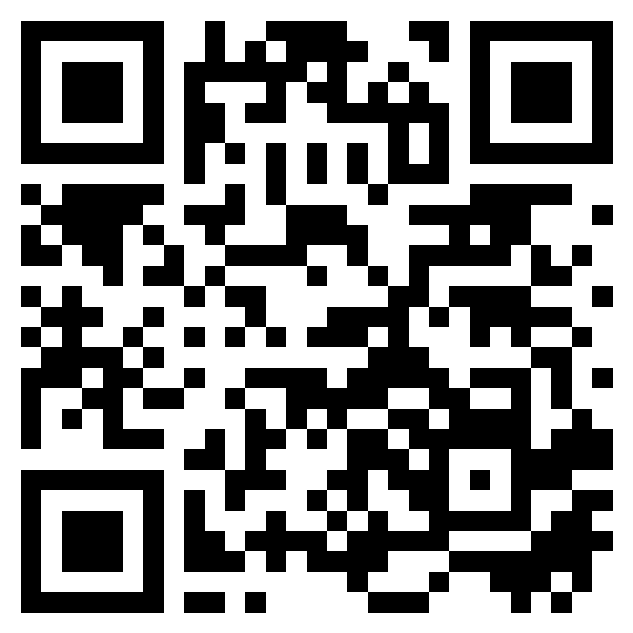
adamborecki.github.io/gym/
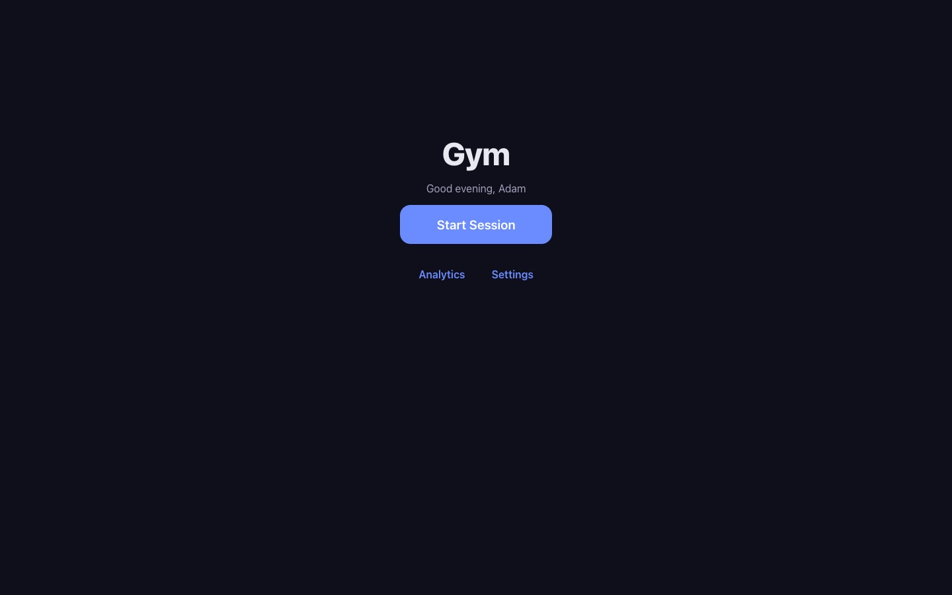
A single-focus workout app that folds four separate fitness apps into one routine.
A personal tool built to replace several subscriptions with one simple screen.
Source code: github.com/adamborecki/gym

PRACTICAL TOOLS

Focus Timer
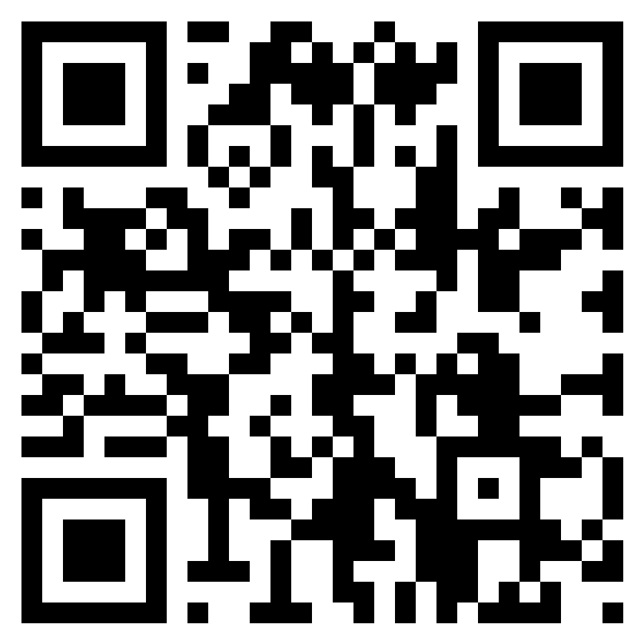
adamborecki.github.io/focus-timer/
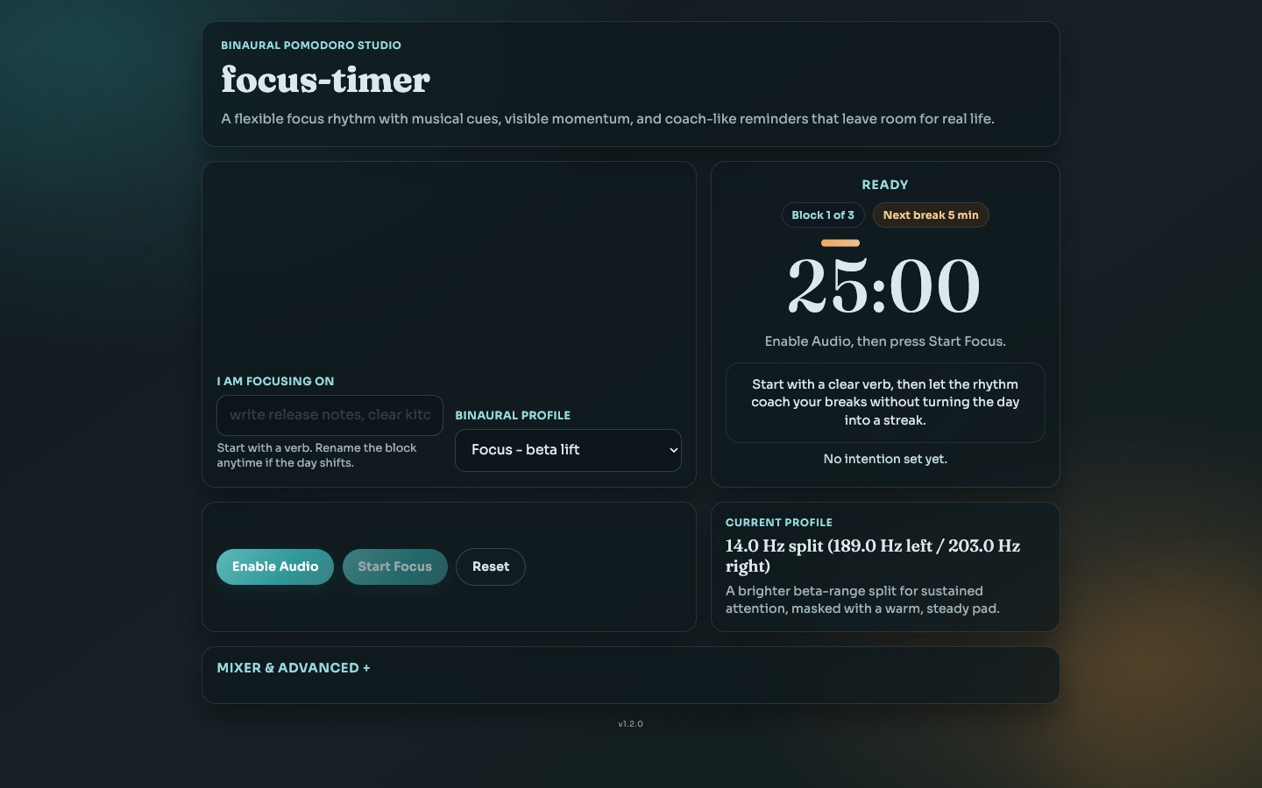
A binaural-beat Pomodoro timer with softer alarms and stretch or walk reminders.
Built for long grading and editing sessions: gentle sound, visible momentum, and reminders that leave room for real life.
Source code: github.com/adamborecki/focus-timer

CONCEPT & VISUAL

Hopfield
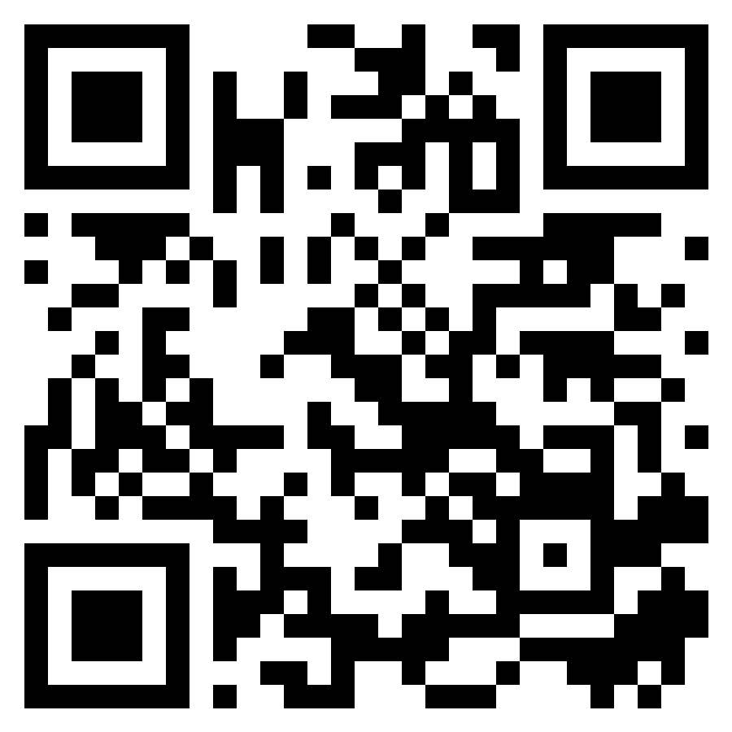
adamborecki.github.io/hopfield1/
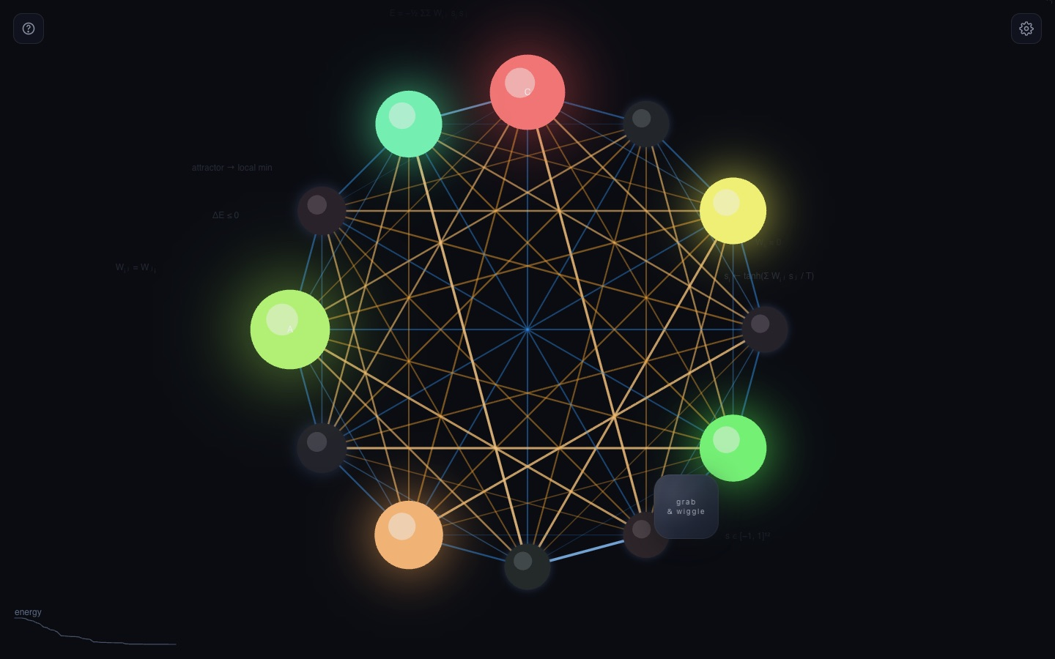
A neural network that listens to itself: grab, wiggle, and watch neurons argue their way into a chord.
A Hopfield network, a classic model of associative memory, rendered as glowing pitch nodes that settle into stable chords.
Source code: github.com/adamborecki/hopfield1

CONCEPT & VISUAL

Hopfield Harmonics
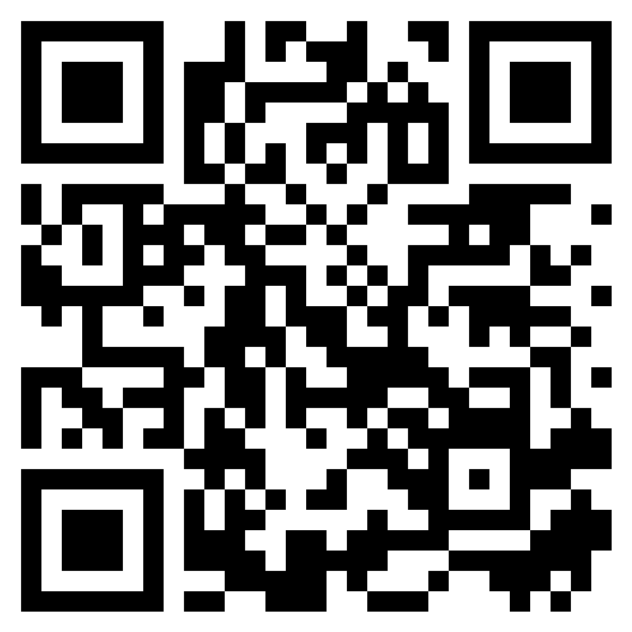
adamborecki.github.io/hopfield2/
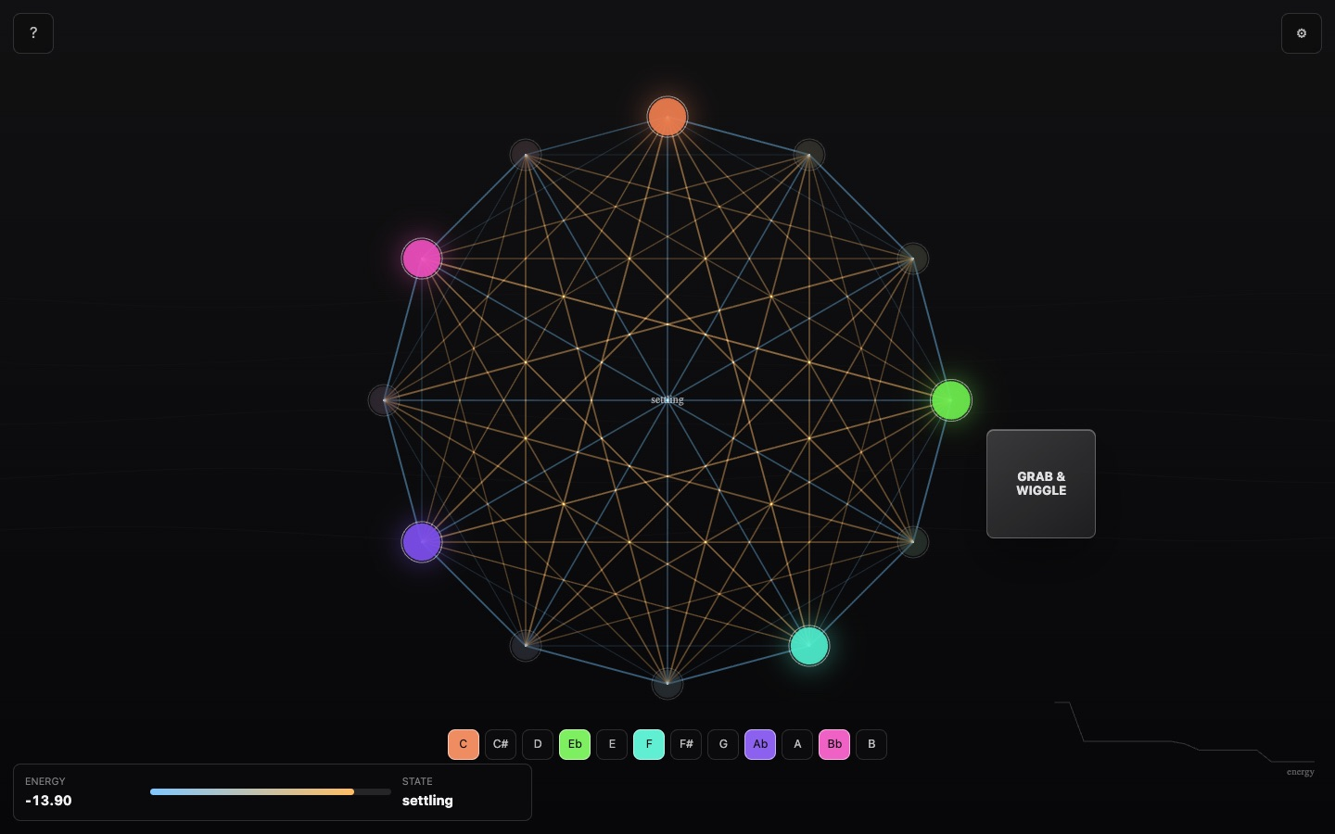
A second pass at the Hopfield experiment: a neural memory tuned by consonance.
Built with a different AI assistant from the first version, as a comparison of approaches to the same idea.
Source code: github.com/adamborecki/hopfield2

CONCEPT & VISUAL

Consciousness
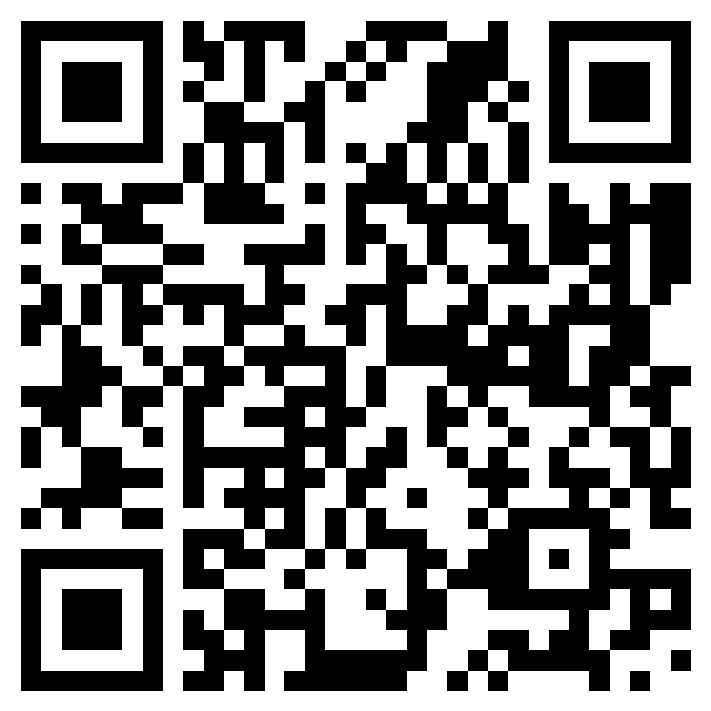
adamborecki.github.io/consciousness/
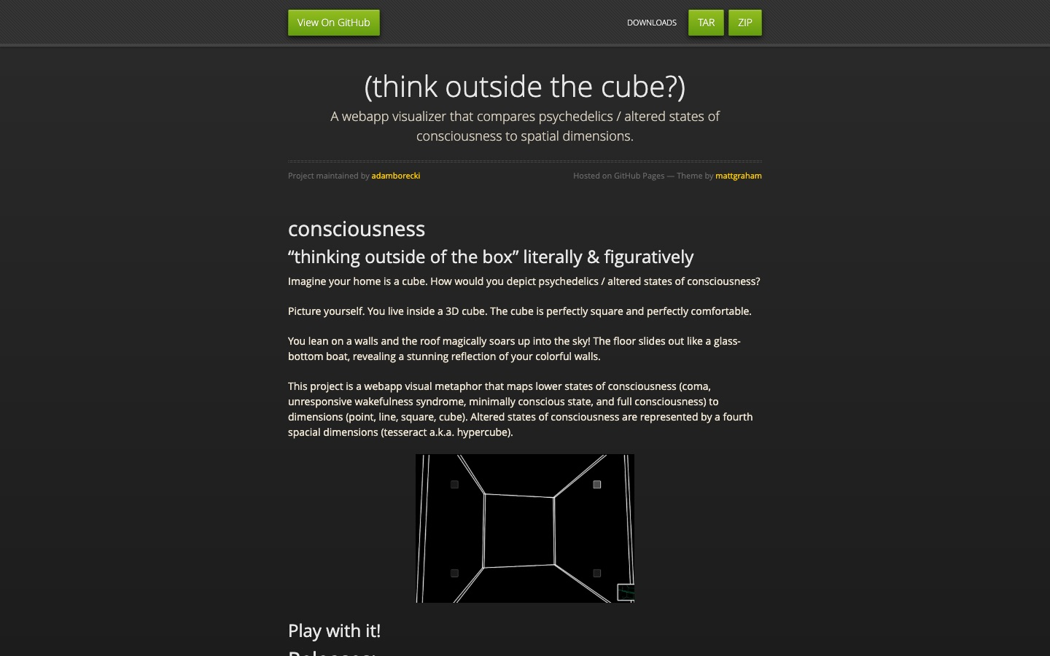
Thinking outside the cube, literally: a visual metaphor that maps states of consciousness to spatial dimensions.
An interactive cube you can step outside of, as a way to talk about perspective.
Source code: github.com/adamborecki/consciousness

CONCEPT & VISUAL

Optics
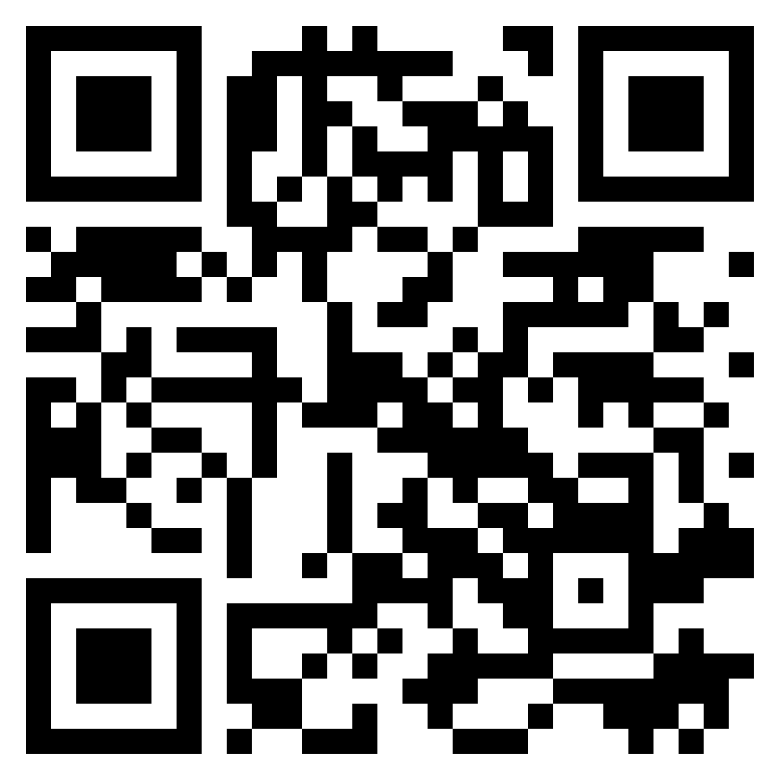
adamborecki.github.io/optics/
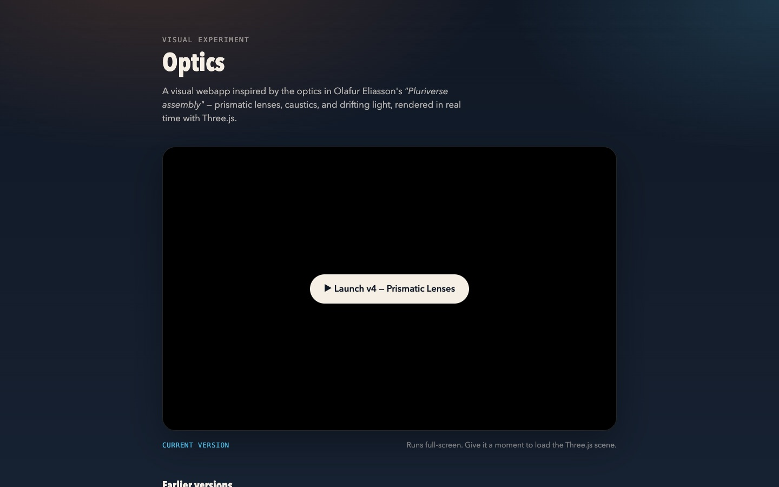
Prismatic lenses, caustics, and drifting light, inspired by Olafur Eliasson’s "Pluriverse assembly."
A series of versions exploring how far real-time graphics in a browser can imitate light through glass.
Source code: github.com/adamborecki/optics

CONCEPT & VISUAL

Spirograph
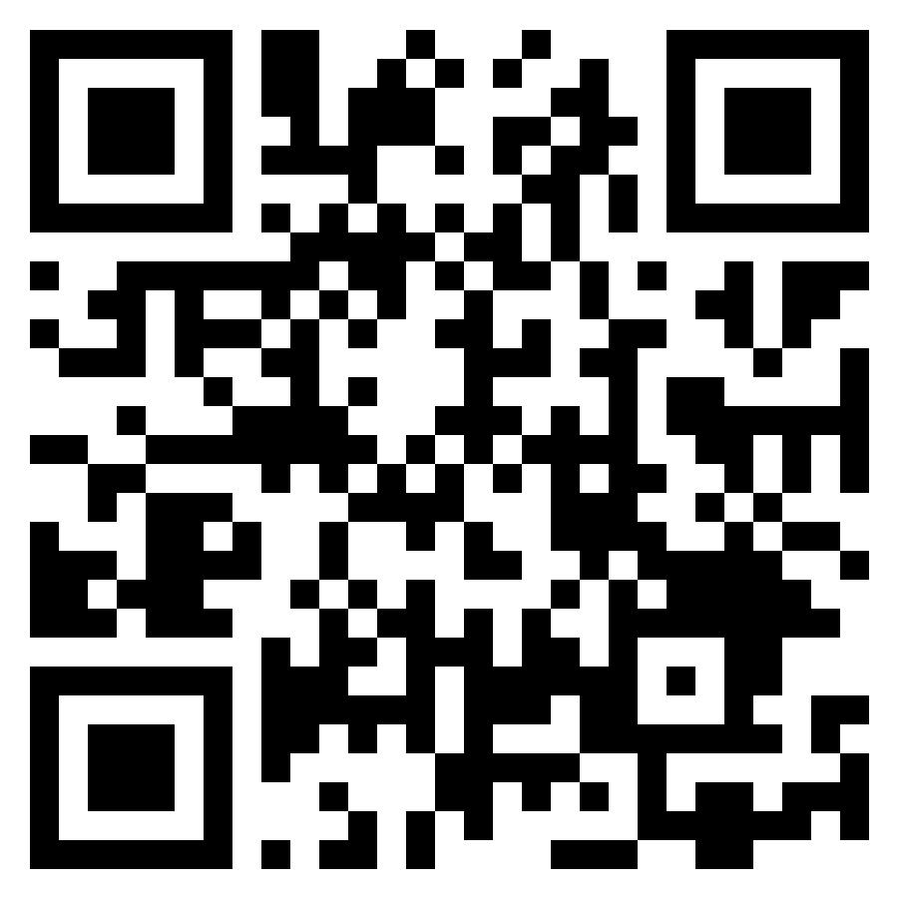
adamborecki.github.io/spirograph/
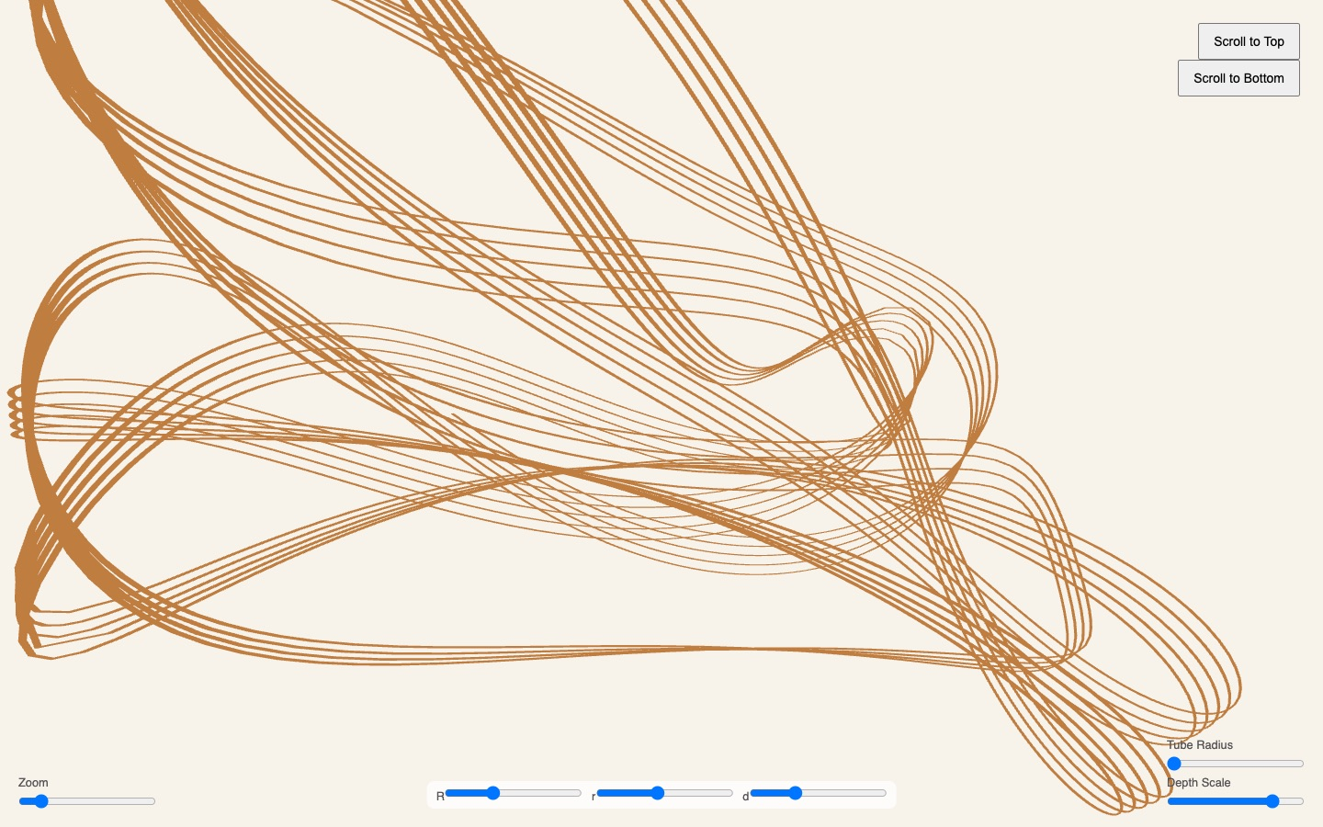
Generative 3D spirograph drawings that unfold as you scroll.
Looping geometric motion rendered as tubes in 3D. Scroll to draw, and use the sliders to change the curve.
Source code: github.com/adamborecki/spirograph

APPENDIX A

Index of all apps
Every app in this book, in page order. All links start with adamborecki.github.io. The full, searchable catalog is at adamborecki.github.io/webapps.
App | Category | Link
Mod FX | Music Technology Education | adamborecki.github.io/mod-fx
Harmonics | Music Technology Education | adamborecki.github.io/harmonics
Harmonic Series Builder | Music Technology Education | adamborecki.github.io/harmonic-series-builder-gen3
Gain Staging | Music Technology Education | adamborecki.github.io/gain-staging
Parallel Compression | Music Technology Education | adamborecki.github.io/parallel
MUS 244 Unit 1 Review | Music Technology Education | adamborecki.github.io/mus244-unit1-review
MUS 244 Unit 1 Slides | Music Technology Education | adamborecki.github.io/mus244-unit1
Sound Lab | Music Technology Education | adamborecki.github.io/sound-lab
Salmon Simulator | Music Technology Education | adamborecki.github.io/salmon
Mixer Lab | Music Technology Education | adamborecki.github.io/mixer-lab
EQ Trainer | Music Technology Education | adamborecki.github.io/eq-webapp
OO-O-AH-A-EE | Music Technology Education | adamborecki.github.io/oo-o-ah-a-ee
Goniometer | Music Technology Education | adamborecki.github.io/goniometer
Comb Filter Lab | Music Technology Education | adamborecki.github.io/comb-filtering
MixCube | Music Technology Education | adamborecki.github.io/mixcube
Mid/Side Processing | Music Technology Education | adamborecki.github.io/mid-side
Sidechain Compression | Music Technology Education | adamborecki.github.io/sidechain
Multiband Dynamics | Music Technology Education | adamborecki.github.io/multiband
Multiband Mayhem | Music Technology Education | adamborecki.github.io/multiband-game
Harmonic Series Builder: Prototype Archive | Music Technology Education | adamborecki.github.io/harmonic-series-builder
Sock Piano | Instruments & Effects | adamborecki.github.io/sock-piano
Uke Chord Buddy | Instruments & Effects | adamborecki.github.io/misc-music-webapps/uke_chord_buddy.html
Me Again | Instruments & Effects | adamborecki.github.io/me-again
There and Back Again | Instruments & Effects | adamborecki.github.io/there-and-back
Misc Music Webapps | Instruments & Effects | adamborecki.github.io/misc-music-webapps
Camera Lab | Multi-Discipline Education | adamborecki.github.io/camera-lab
MUS 248 Activities | Multi-Discipline Education | adamborecki.github.io/mus248
Sight Reading | Multi-Discipline Education | adamborecki.github.io/sight-reading
Instruments | Multi-Discipline Education | adamborecki.github.io/instruments
Mahler’s First | Multi-Discipline Education | adamborecki.github.io/mahler1
Turangalîla | Multi-Discipline Education | adamborecki.github.io/turangalila
Turandot: The Video Game | Multi-Discipline Education | adamborecki.github.io/turandot
8 Tiny Japanese Habits | Multi-Discipline Education | adamborecki.github.io/from-japan
Quiz | Multi-Discipline Education | adamborecki.github.io/quiz
Note Detection | Multi-Discipline Education | adamborecki.github.io/misc-music-webapps/note_detection_v2.html
The Four Seasons | Multi-Discipline Education | adamborecki.github.io/four-seasons
Gym | Practical Tools | adamborecki.github.io/gym
Focus Timer | Practical Tools | adamborecki.github.io/focus-timer
Hopfield | Concept & Visual | adamborecki.github.io/hopfield1
Hopfield Harmonics | Concept & Visual | adamborecki.github.io/hopfield2
Consciousness | Concept & Visual | adamborecki.github.io/consciousness
Optics | Concept & Visual | adamborecki.github.io/optics
Spirograph | Concept & Visual | adamborecki.github.io/spirograph

APPENDIX B

Glossary
Useful terms for talking about AI-assisted, front-end web apps.
Web app. A program that runs in a web browser. Nothing to install: open a link, and it works on a laptop, tablet, or phone.
Front-end only. Everything runs in the visitor’s browser. There is no server, database, or login, so the apps are cheap to host, private by default, and hard to break.
Vibe coding. Building software by describing what you want to an AI assistant in plain language, testing the result, and steering with feedback, rather than writing every line yourself.
AI coding assistant. A large language model (such as Claude, ChatGPT, Gemini, or GitHub Copilot) that writes, explains, and edits code in conversation.
Prompt. The instructions you give an AI assistant. Good prompts describe the audience, the goal, and what "done" looks like.
HTML / CSS / JavaScript. The three languages of the web: HTML is the content and structure, CSS is the look, and JavaScript is the behavior.
Single-file app. A whole app in one .html file. It is easy to share, easy to host, and easy for an AI assistant to read in full.
Web Audio API. The browser’s built-in audio engine. It can generate, filter, analyze, and record sound in real time, which powers most of the music apps in this book.
Canvas / WebGL. Browser drawing surfaces for 2D and accelerated 3D graphics, used for scopes, spectrograms, simulators, and visual pieces.
GitHub. A website that stores code in "repositories" (repos) and keeps a full history of every change.
GitHub Pages. Free web hosting from GitHub. Any repo can publish itself at username.github.io/repo-name.
Repository (repo). A project folder tracked by Git, including its full history.
Commit. A saved snapshot of changes, with a message describing what changed.
QR code. A square barcode that a phone camera turns into a link. Every app page in this book has one.
Responsive design. Layouts that adapt to the screen, so the same app works on a phone and on a projector.
Iteration. The build, test, and refine loop. Most apps here went through many short rounds of "try it, notice what’s wrong, ask for a fix."

APPENDIX C

How these apps are built
Every app in this book is a static, front-end-only web page: HTML, CSS, and JavaScript running in the browser. There are no servers, accounts, or databases. When an app records audio or saves progress, the data stays on the student’s own device.
Sound comes from the Web Audio API, the audio engine built into every modern browser. Visuals use Canvas and WebGL, and a few apps add small open-source libraries (for example, VexFlow for music notation, Tone.js for scheduling, and three.js for 3D).
Each app lives in its own GitHub repository and is published for free with GitHub Pages. Pushing a change to GitHub updates the live site within a minute or two, which makes it easy to fix a typo between classes.
The code was written in conversation with AI coding assistants (mainly Claude, with ChatGPT, Gemini, and GitHub Copilot along the way), under my direction. My role was the subject-matter expert, designer, and tester: deciding what students need to learn, describing it clearly, trying every build, and pushing back when something was wrong or confusing.
Several apps were built more than once on purpose. The Harmonic Series Builder prototype archive shows one prompt given to three different assistants, and Hopfield 1 and 2 compare two tools on the same idea.

The toolkit
Languages: HTML, CSS, and JavaScript (with TypeScript and React in Sight Reading)
Audio: Web Audio API, Tone.js
Graphics: Canvas 2D, WebGL / WebGL2, three.js, VexFlow (notation)
Hosting: GitHub repositories + GitHub Pages (free)
AI assistants: Claude (Claude Code), ChatGPT / Codex, Gemini, GitHub Copilot
Cost to run: $0 per month in hosting; no servers or accounts

APPENDIX D

Build your own
You don’t need to know how to code to make a useful classroom web app. Here is the process I use.
1. Start with one teaching moment. Pick a concept students struggle with that would be clearer if they could touch it, hear it, or see it move. Small and specific beats big and general.
2. Write the brief before you prompt. In a paragraph: who it’s for, what they should be able to do afterward, what the screen should show, and what "done" looks like. Paste that in as your first prompt.
3. Ask for a single HTML file. "Build this as one self-contained HTML file with no build step." That keeps it easy to save, open, share, and host.
4. Open it and actually use it. Double-click the file to run it in your browser. Try it on your phone. Note everything that is wrong, confusing, or missing.
5. Iterate in short rounds. Give specific feedback ("the slider is too small on a phone," "the second step is confusing because…") and ask for one change at a time. Expect ten or more rounds.
6. Check the content yourself. The AI writes code quickly, but you are the expert. Verify every fact, definition, and answer key before students see it.
7. Publish it free on GitHub Pages. Create a GitHub account and a new repository, upload the file as index.html, then turn on Pages in Settings. Your app goes live at username.github.io/repo-name.
8. Share it with a QR code. Put the link on a slide or a handout as a QR code so students can open it on their phones in seconds.
9. Disclose and reflect. Tell students how the tool was made. Many of these apps include a short AI-use note, which also starts good conversations about AI in the field.

A starter prompt
"I teach [course] to [students]. They struggle to understand [concept]. Build a single self-contained HTML file (no build step, no external server) that lets a student [interaction]. It should work on a phone and on a classroom projector, make sound only after a Start button is pressed, and include a short explanation and a 3-question self-check at the end."
Questions or ideas? Find everything at adamborecki.github.io/webapps.

